Part 1

[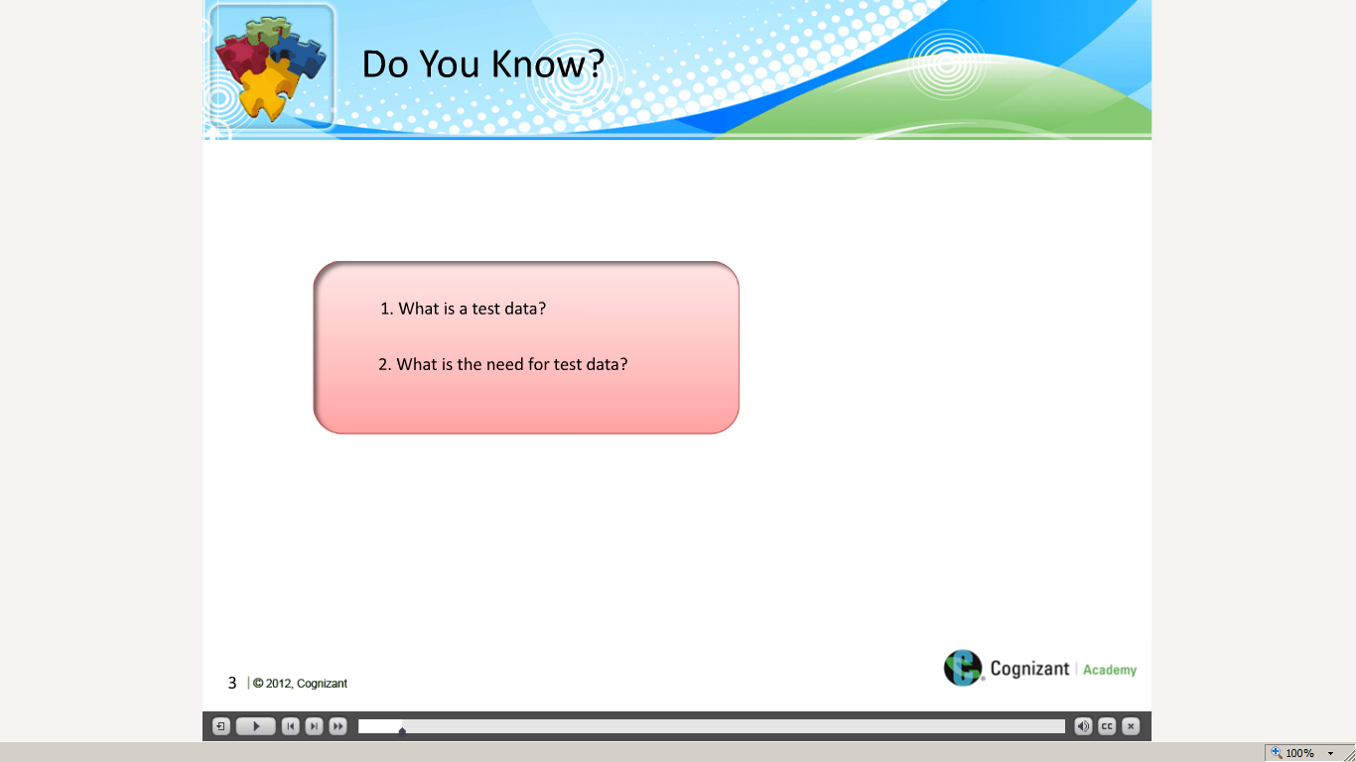](https://compass.learning.cognizant.com/elmprd/elearning/test_data_preparation_overview/multiscreen.html)

[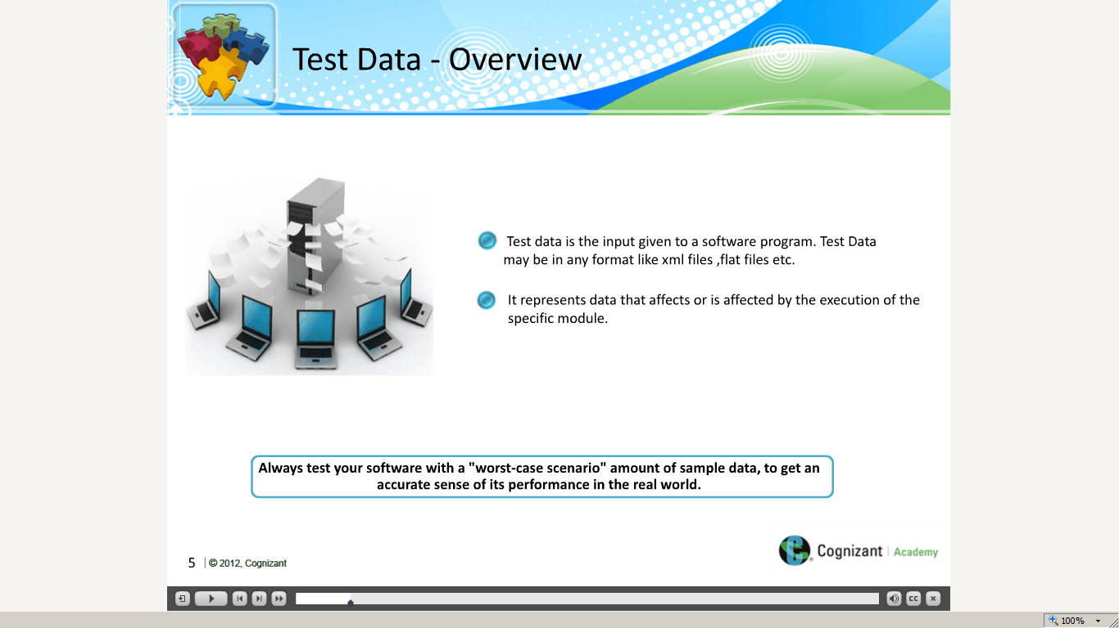](https://compass.learning.cognizant.com/elmprd/elearning/test_data_preparation_overview/multiscreen.html)

[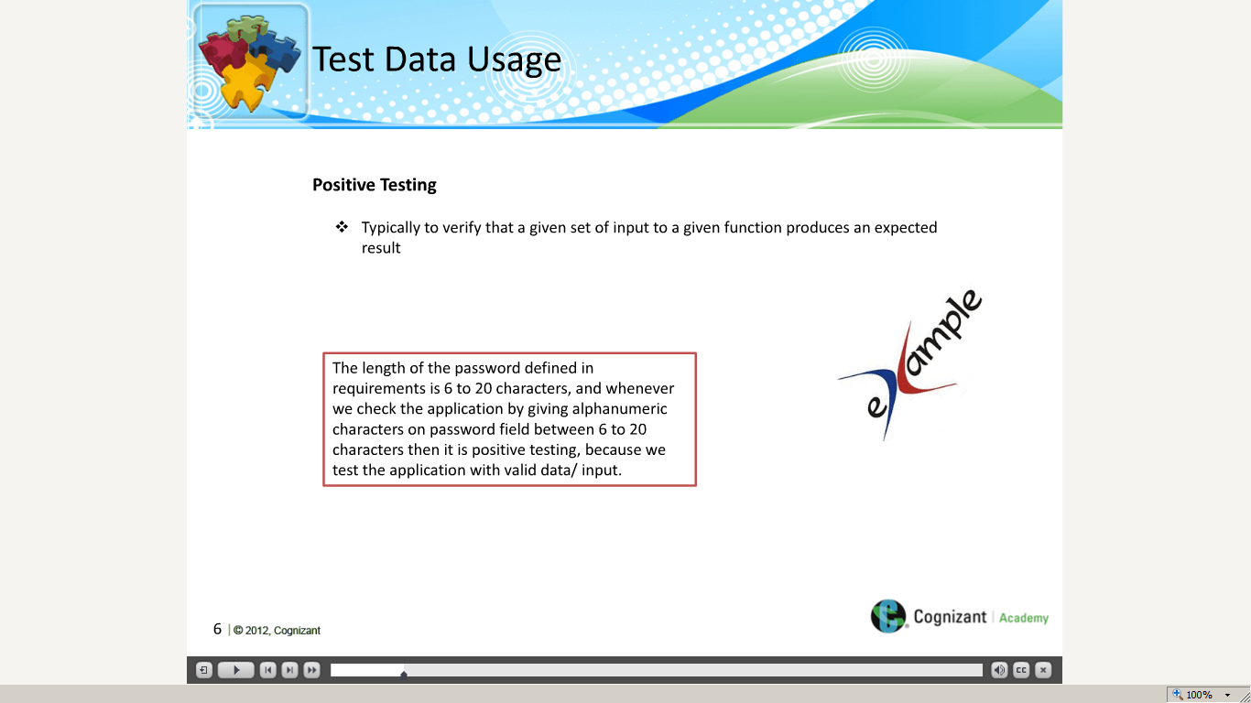](https://compass.learning.cognizant.com/elmprd/elearning/test_data_preparation_overview/multiscreen.html)

[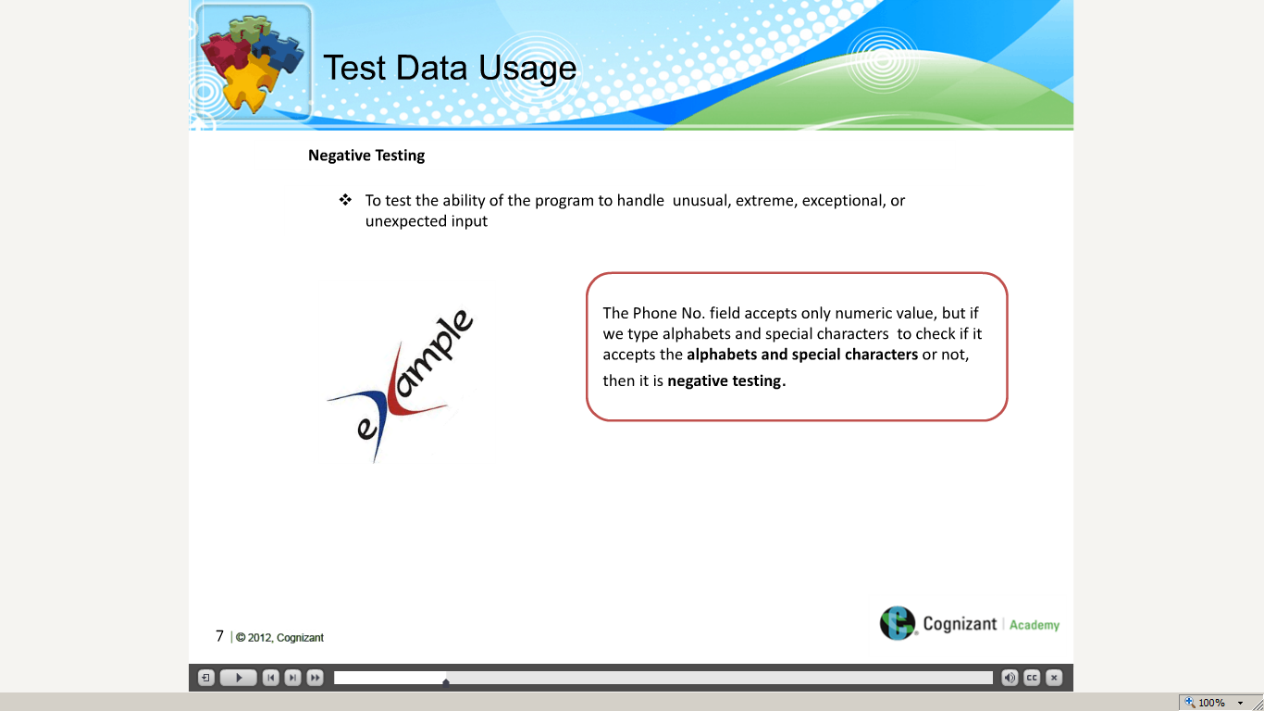](https://compass.learning.cognizant.com/elmprd/elearning/test_data_preparation_overview/multiscreen.html)

[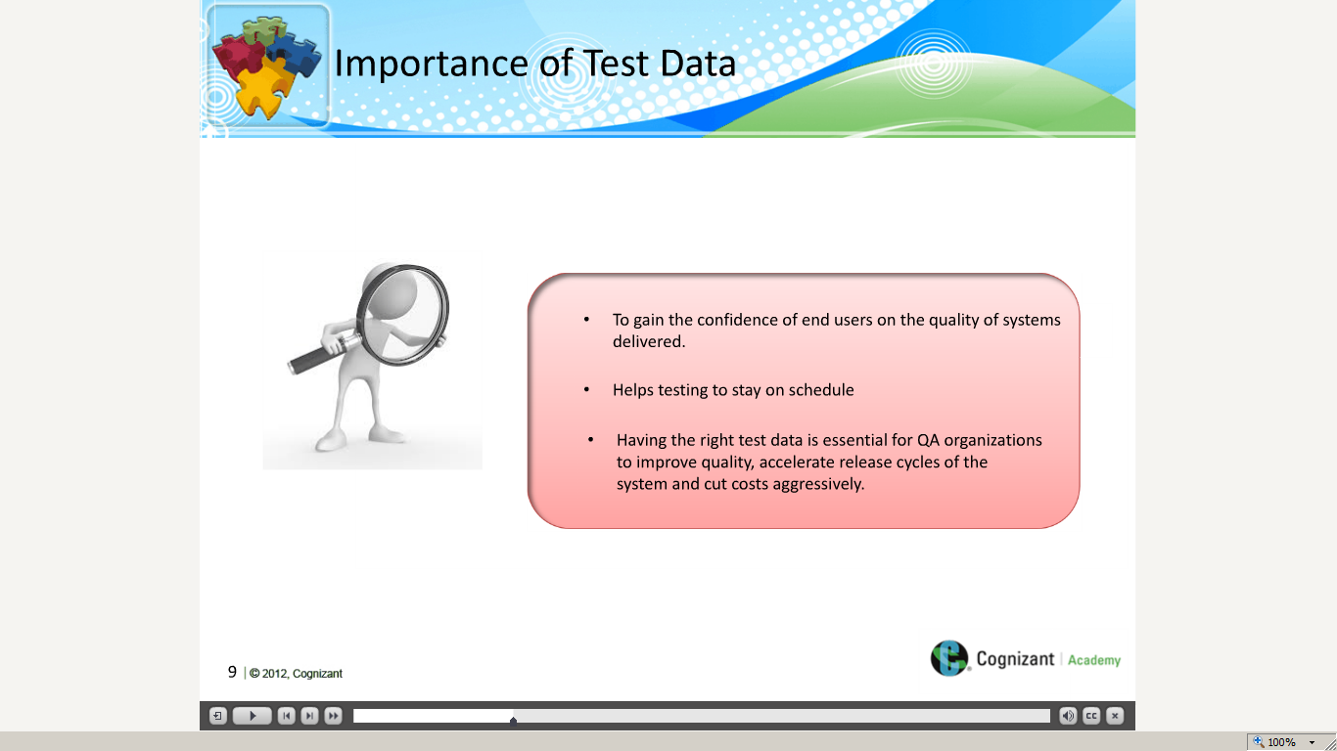](https://compass.learning.cognizant.com/elmprd/elearning/test_data_preparation_overview/multiscreen.html)

[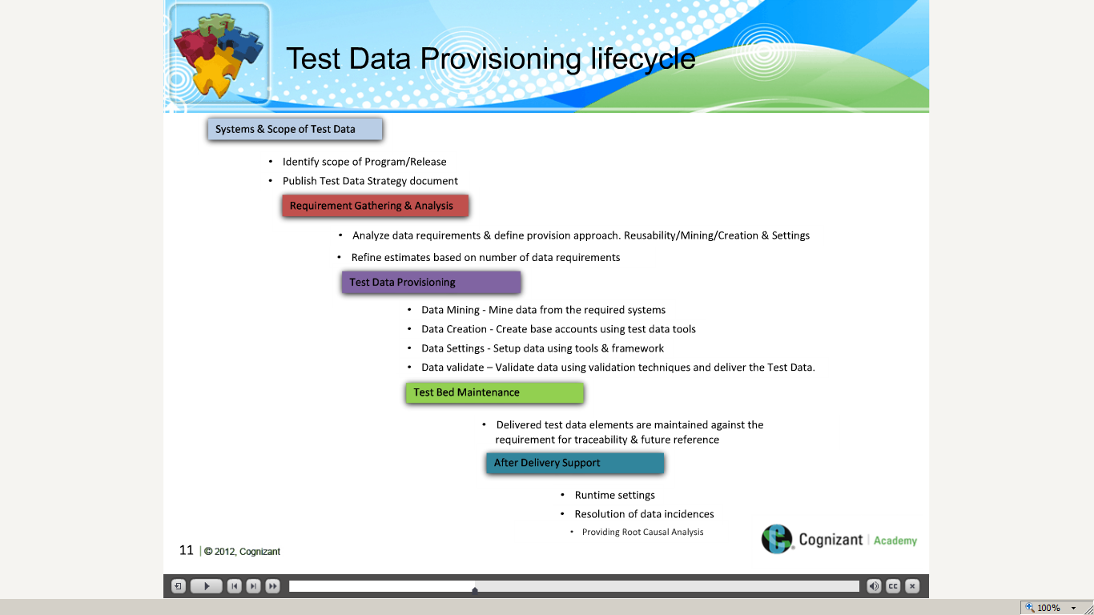](https://compass.learning.cognizant.com/elmprd/elearning/test_data_preparation_overview/multiscreen.html)

[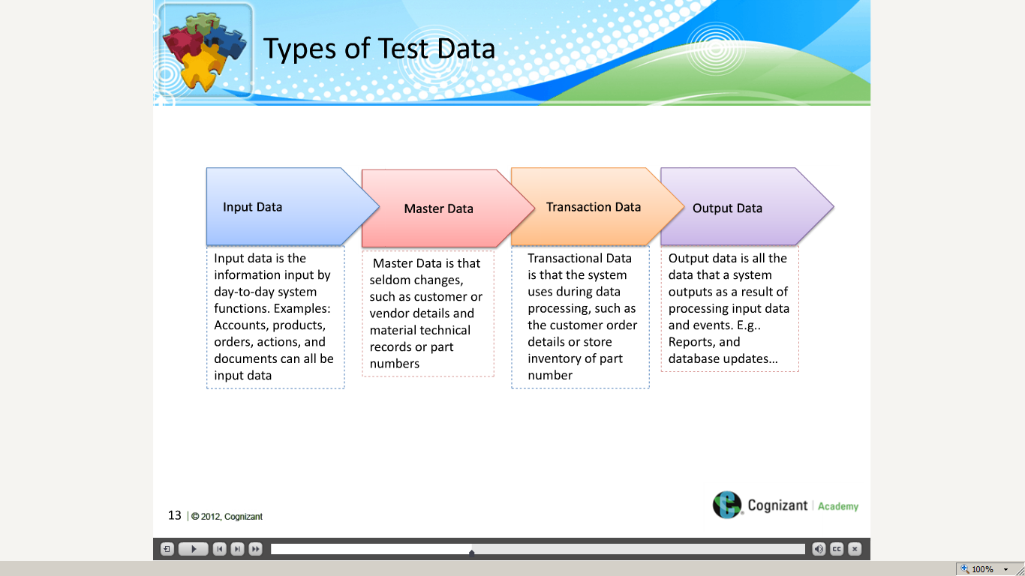](https://compass.learning.cognizant.com/elmprd/elearning/test_data_preparation_overview/multiscreen.html)

[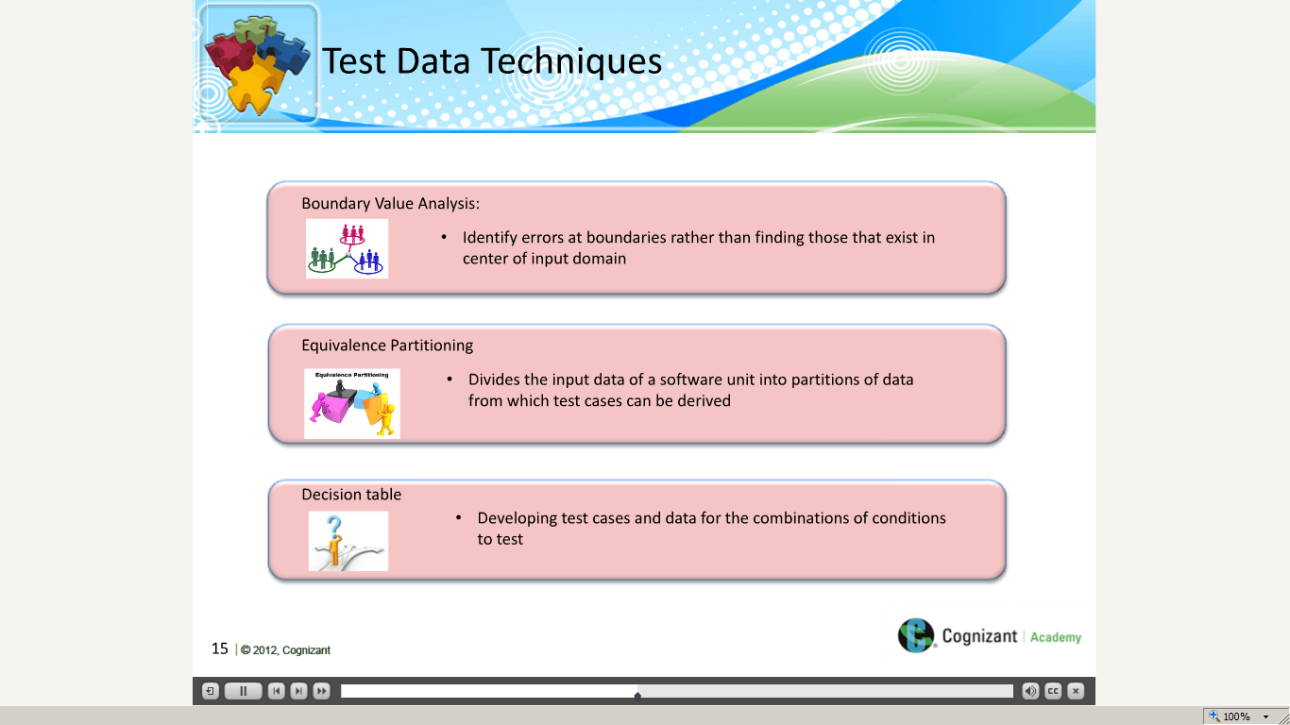](https://compass.learning.cognizant.com/elmprd/elearning/test_data_preparation_overview/multiscreen.html)

[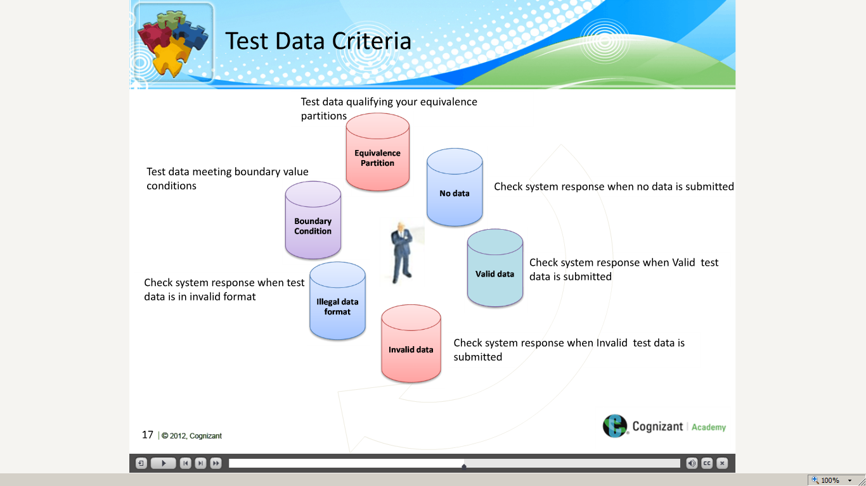](https://compass.learning.cognizant.com/elmprd/elearning/test_data_preparation_overview/multiscreen.html)

[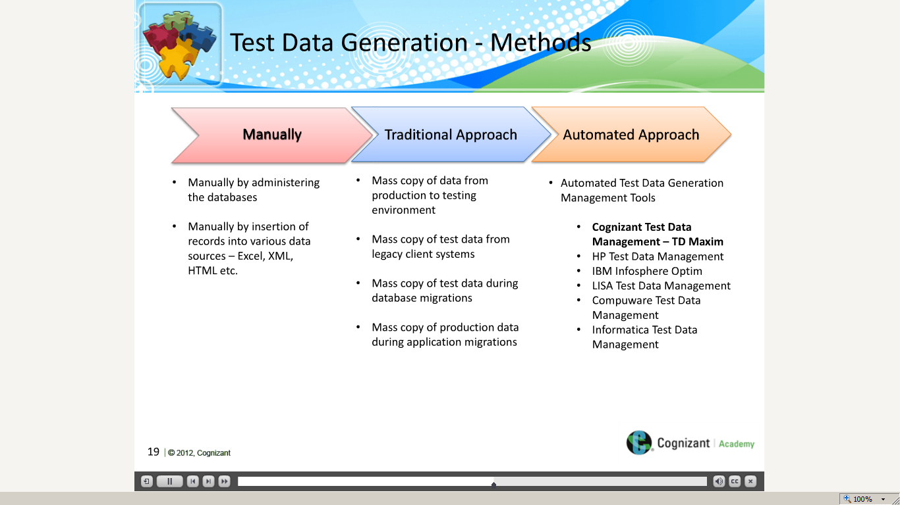](https://compass.learning.cognizant.com/elmprd/elearning/test_data_preparation_overview/multiscreen.html)

[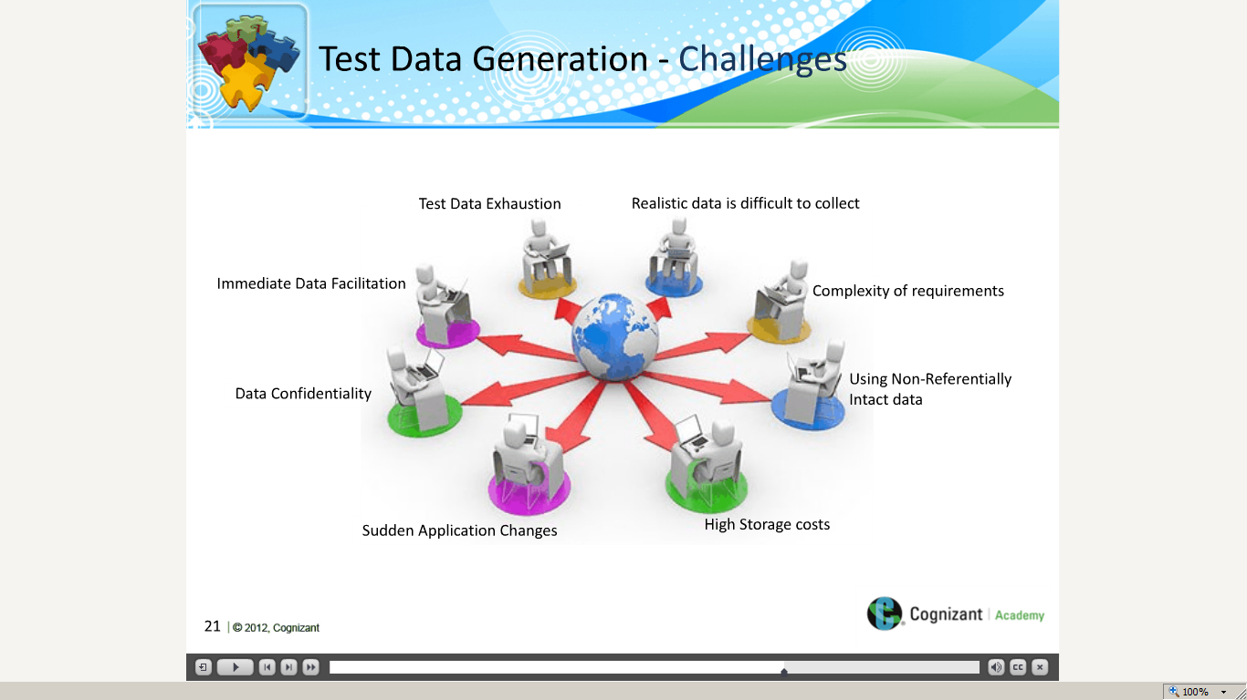](https://compass.learning.cognizant.com/elmprd/elearning/test_data_preparation_overview/multiscreen.html)

[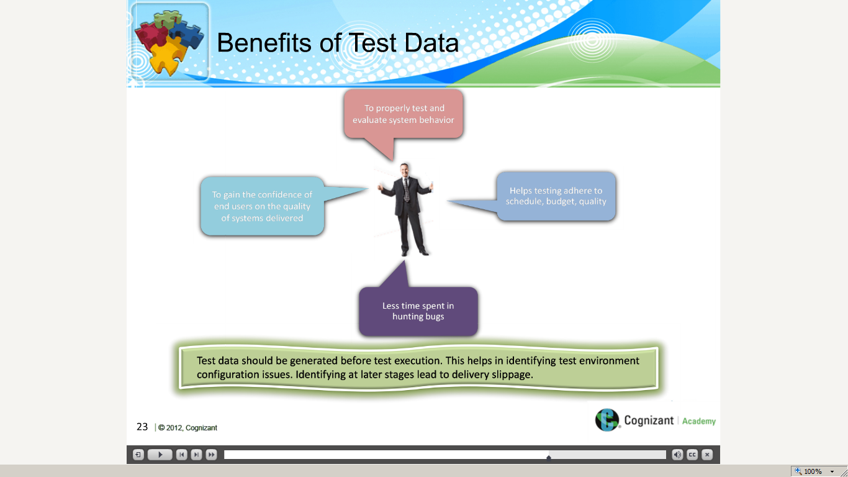](https://compass.learning.cognizant.com/elmprd/elearning/test_data_preparation_overview/multiscreen.html)

[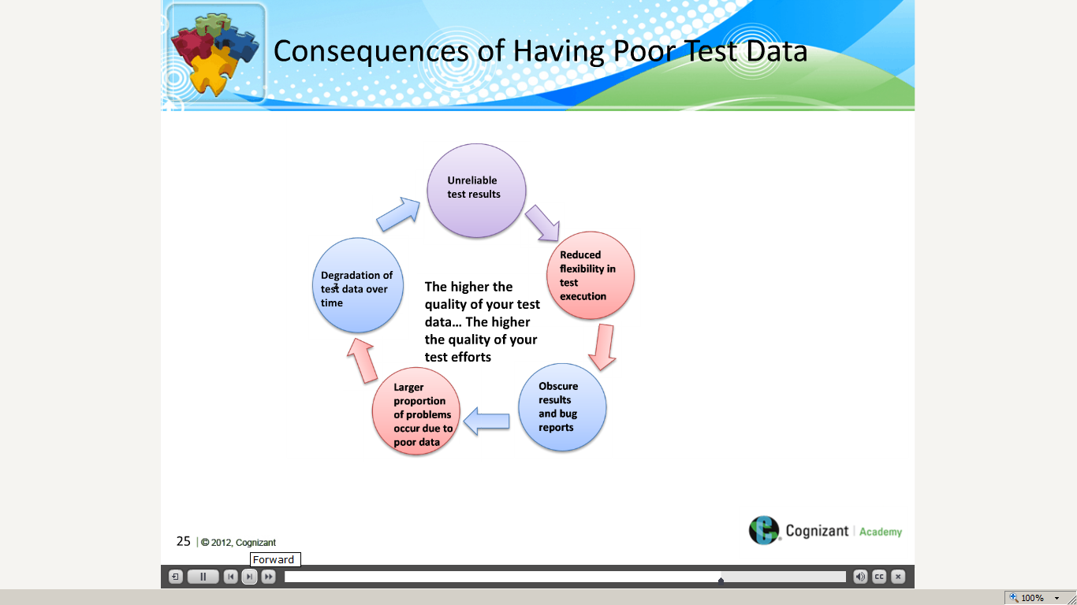](https://compass.learning.cognizant.com/elmprd/elearning/test_data_preparation_overview/multiscreen.html)

[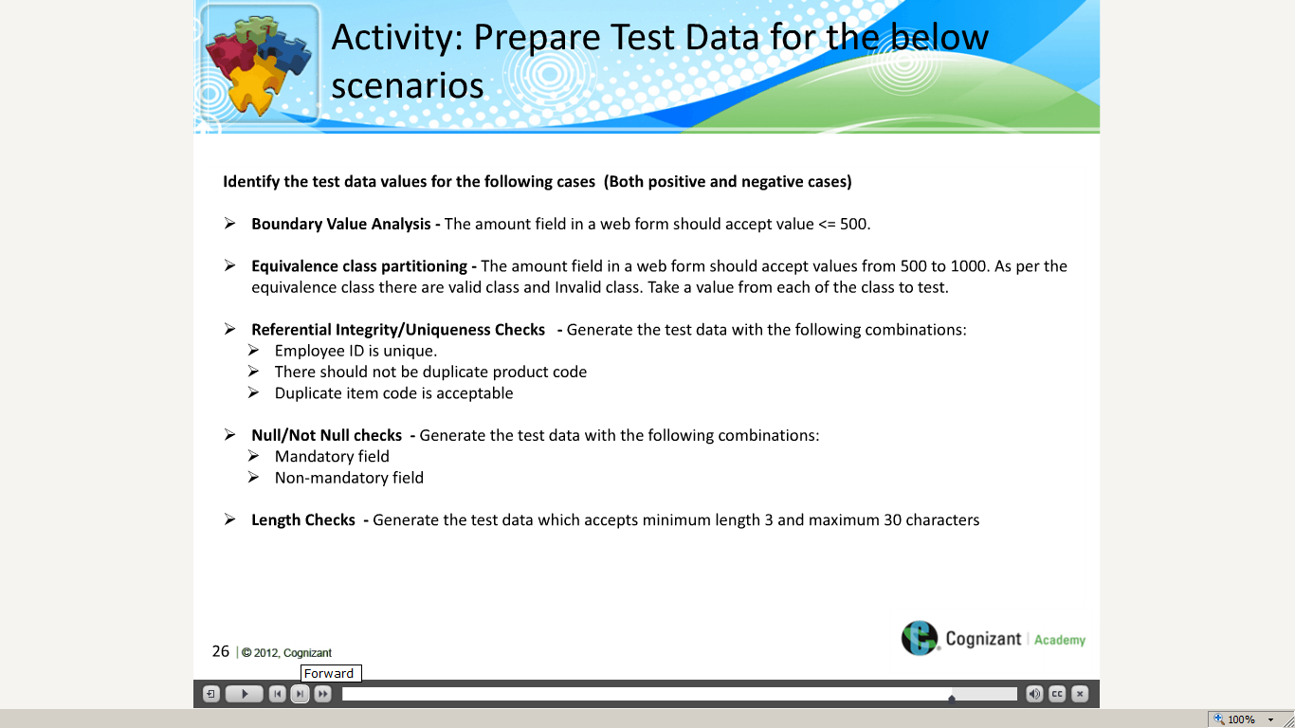](https://compass.learning.cognizant.com/elmprd/elearning/test_data_preparation_overview/multiscreen.html)

[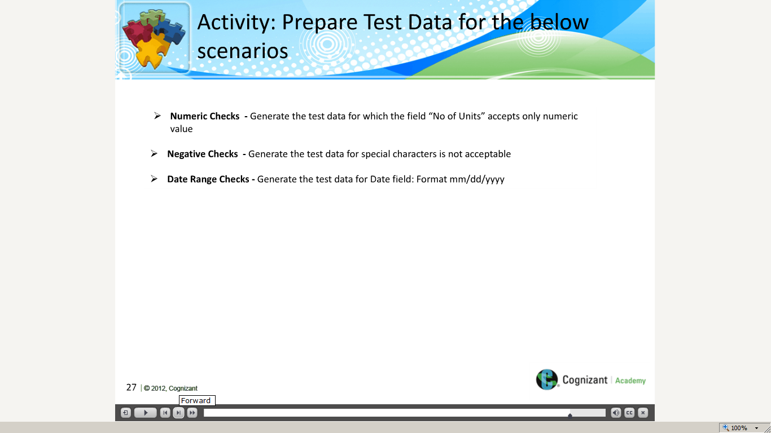](https://compass.learning.cognizant.com/elmprd/elearning/test_data_preparation_overview/multiscreen.html)

[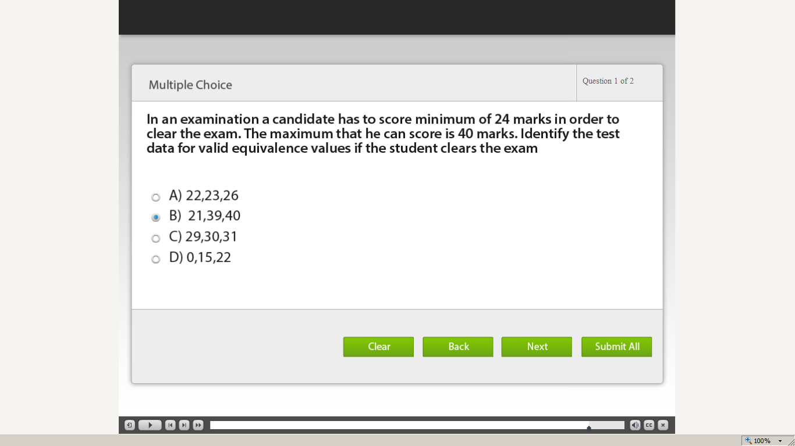](https://compass.learning.cognizant.com/elmprd/elearning/test_data_preparation_overview/multiscreen.html)

[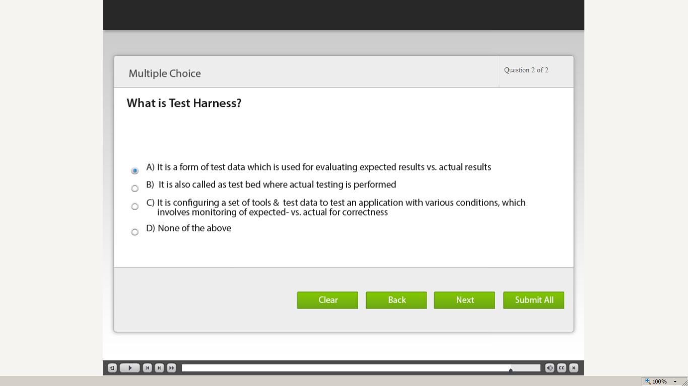](https://compass.learning.cognizant.com/elmprd/elearning/test_data_preparation_overview/multiscreen.html)

[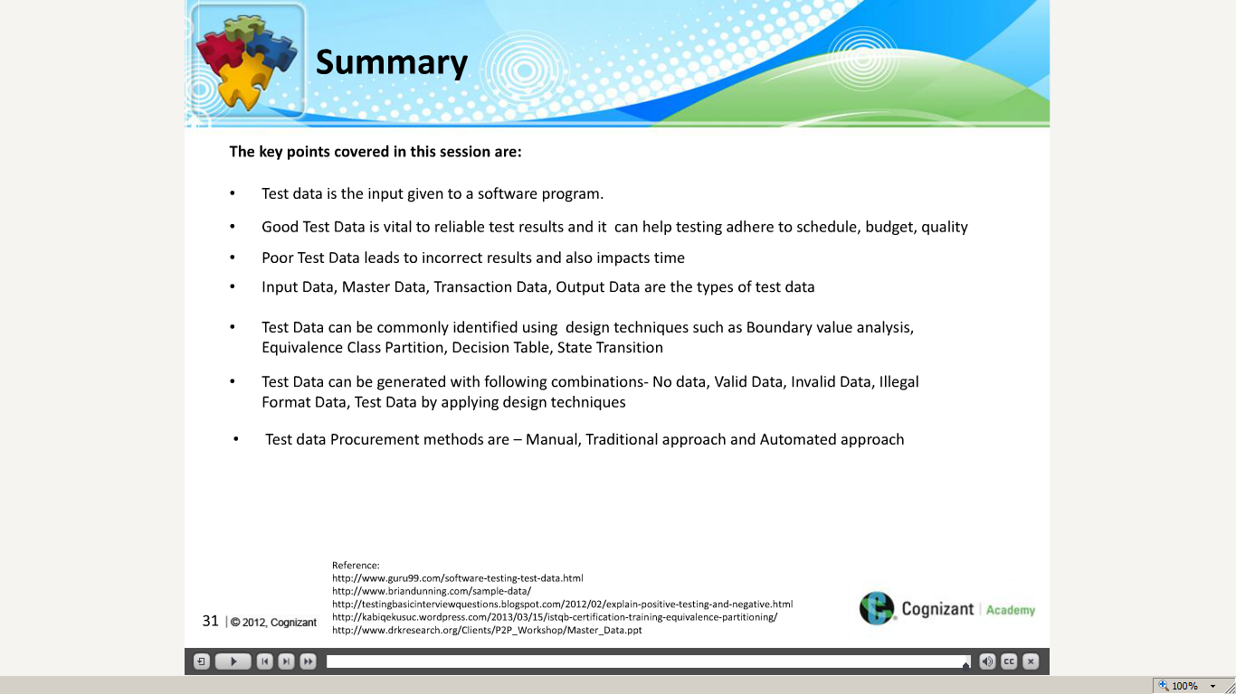](https://compass.learning.cognizant.com/elmprd/elearning/test_data_preparation_overview/multiscreen.html)

Part 2

[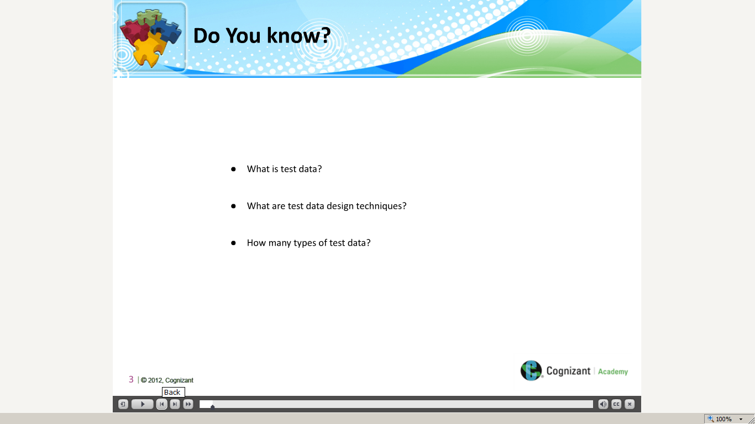](https://compass.learning.cognizant.com/elmprd/elearning/test_data_generation_methods/multiscreen.html)

[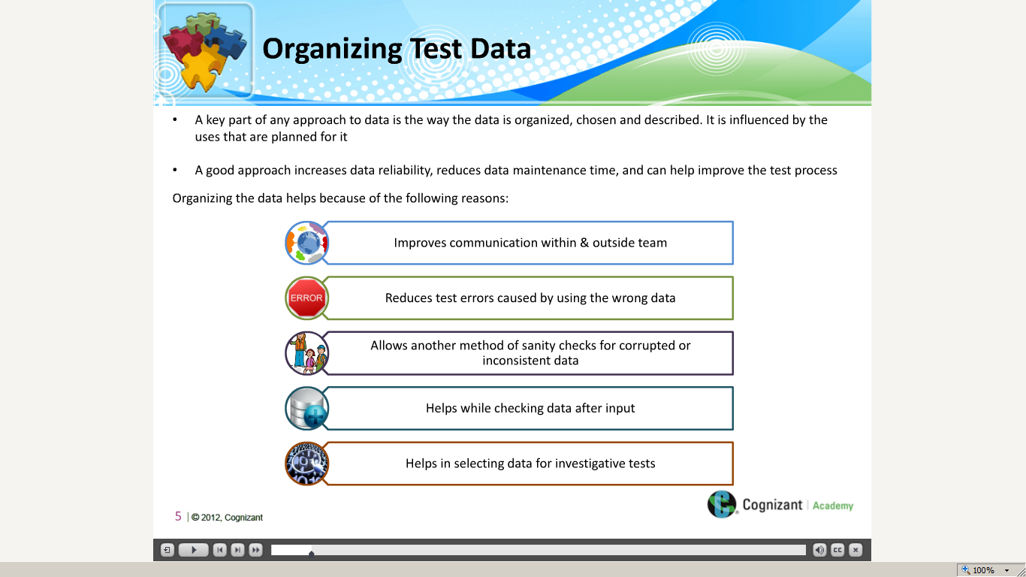](https://compass.learning.cognizant.com/elmprd/elearning/test_data_generation_methods/multiscreen.html)

[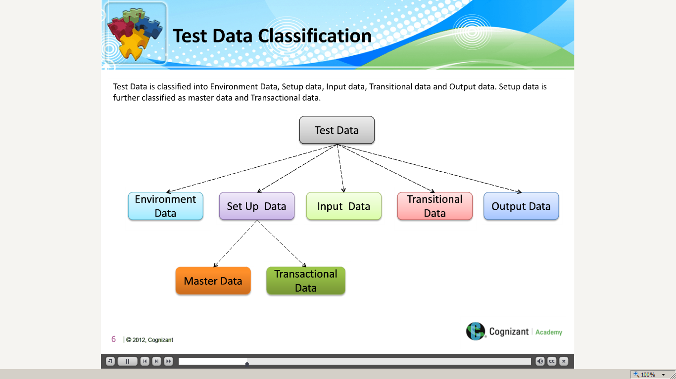](https://compass.learning.cognizant.com/elmprd/elearning/test_data_generation_methods/multiscreen.html)

[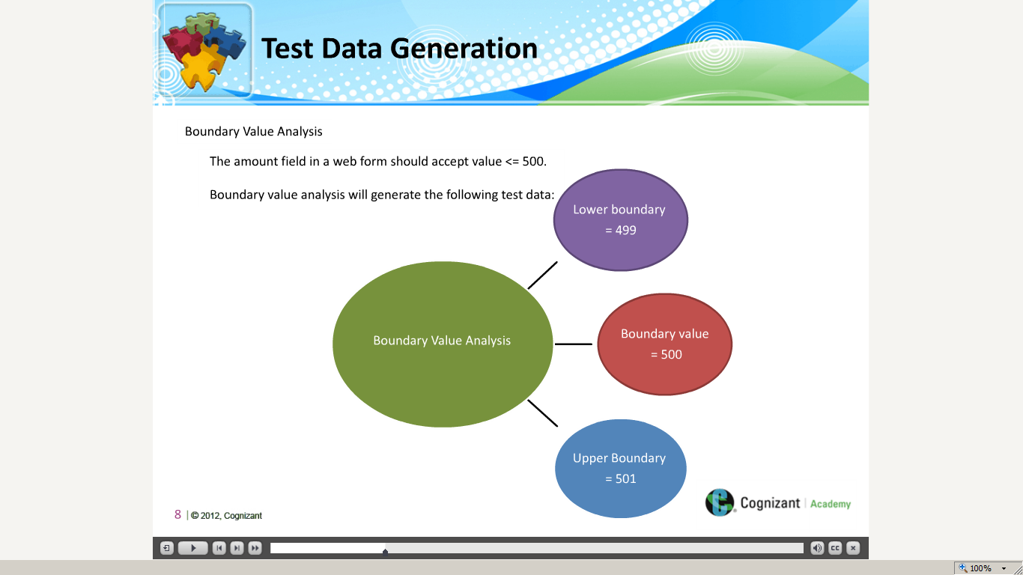](https://compass.learning.cognizant.com/elmprd/elearning/test_data_generation_methods/multiscreen.html)

[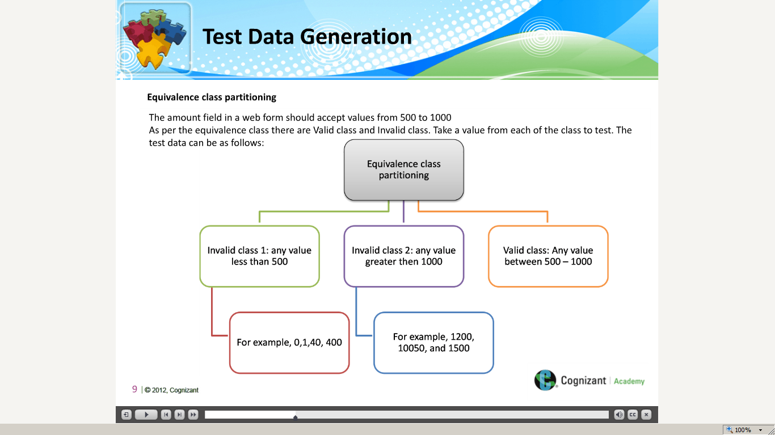](https://compass.learning.cognizant.com/elmprd/elearning/test_data_generation_methods/multiscreen.html)

[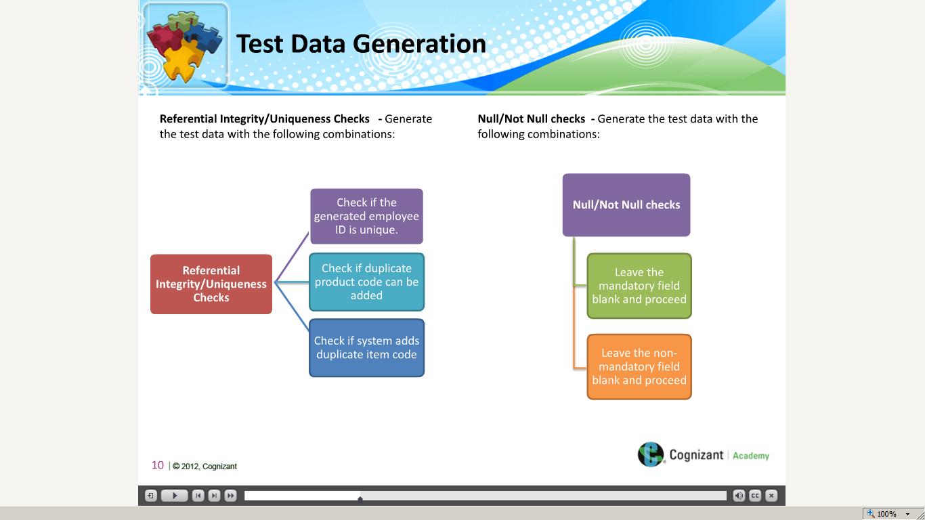](https://compass.learning.cognizant.com/elmprd/elearning/test_data_generation_methods/multiscreen.html)

[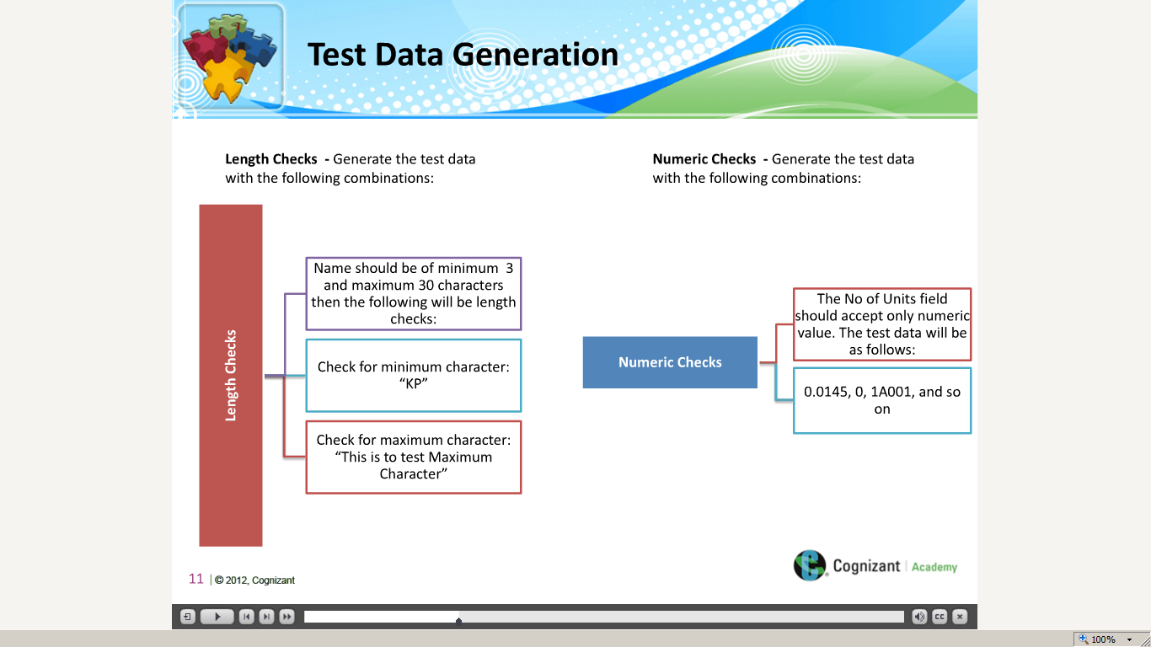](https://compass.learning.cognizant.com/elmprd/elearning/test_data_generation_methods/multiscreen.html)

[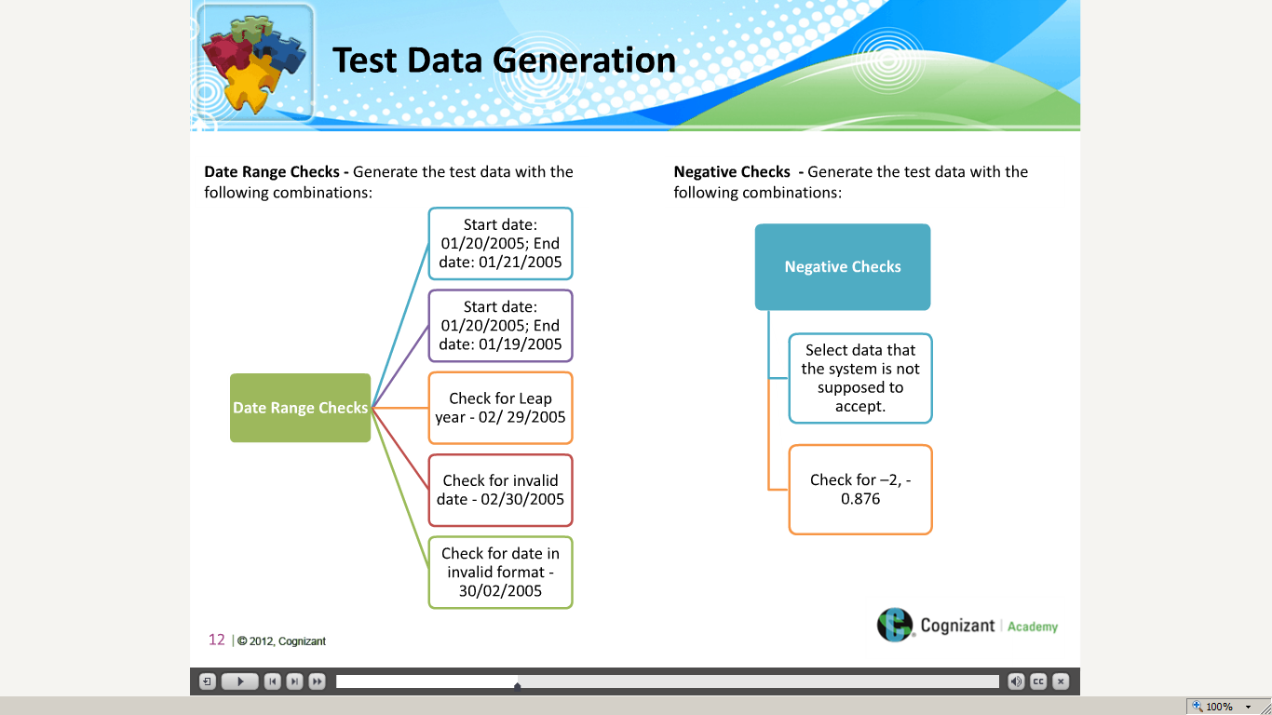](https://compass.learning.cognizant.com/elmprd/elearning/test_data_generation_methods/multiscreen.html)

[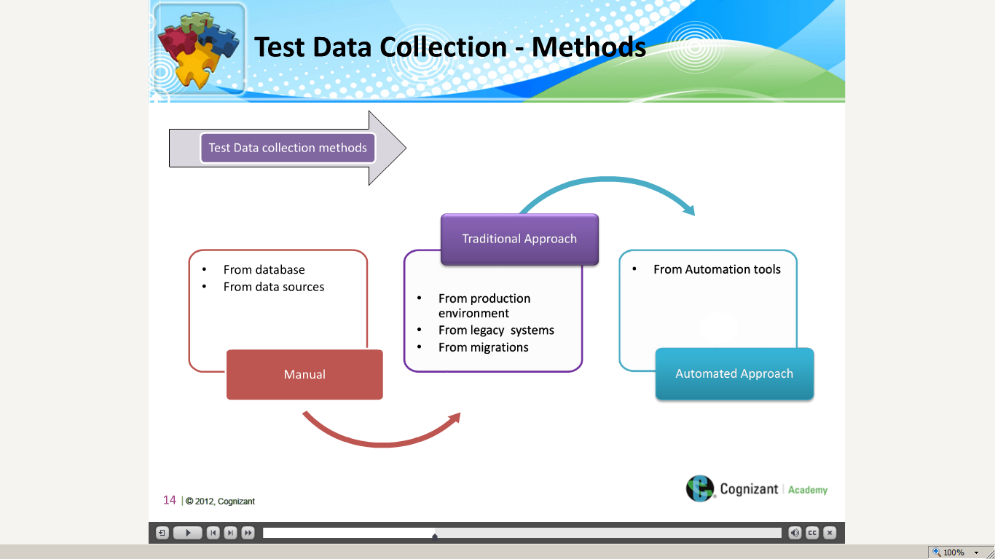](https://compass.learning.cognizant.com/elmprd/elearning/test_data_generation_methods/multiscreen.html)

[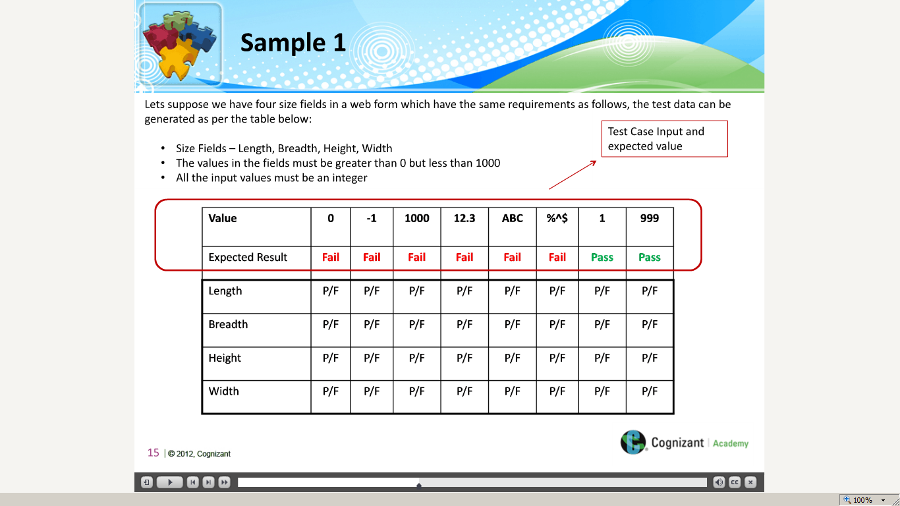](https://compass.learning.cognizant.com/elmprd/elearning/test_data_generation_methods/multiscreen.html)

[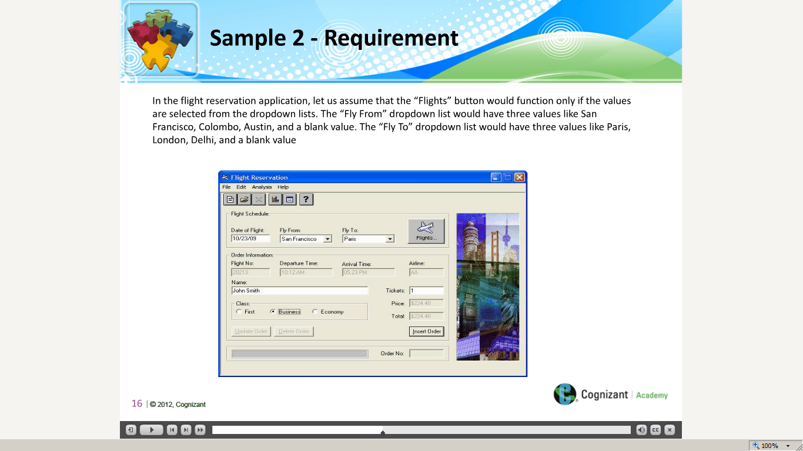](https://compass.learning.cognizant.com/elmprd/elearning/test_data_generation_methods/multiscreen.html)

[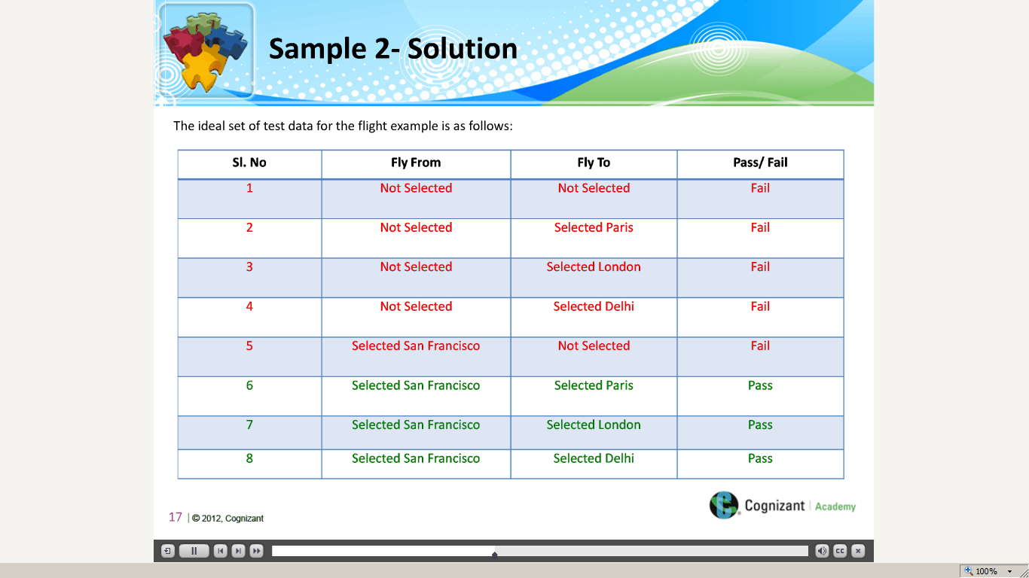](https://compass.learning.cognizant.com/elmprd/elearning/test_data_generation_methods/multiscreen.html)

[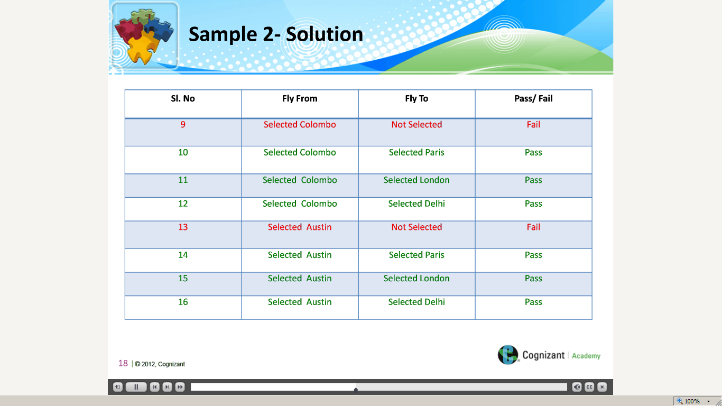](https://compass.learning.cognizant.com/elmprd/elearning/test_data_generation_methods/multiscreen.html)

[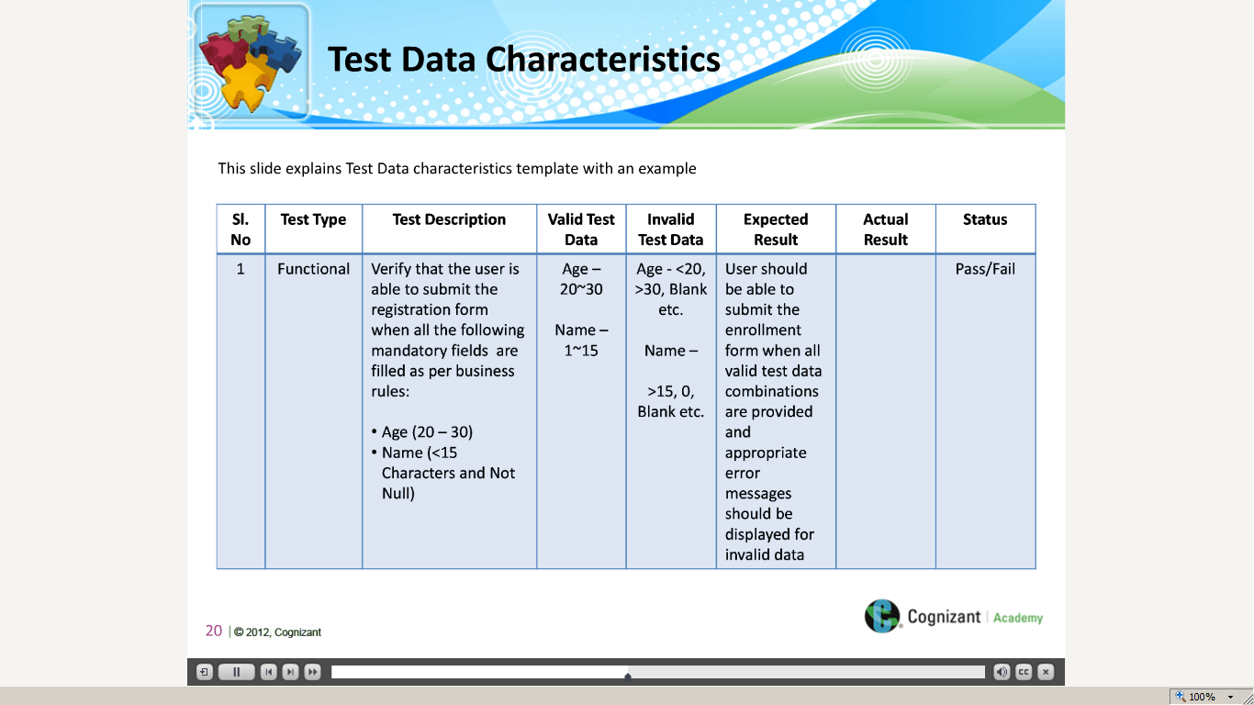](https://compass.learning.cognizant.com/elmprd/elearning/test_data_generation_methods/multiscreen.html)

[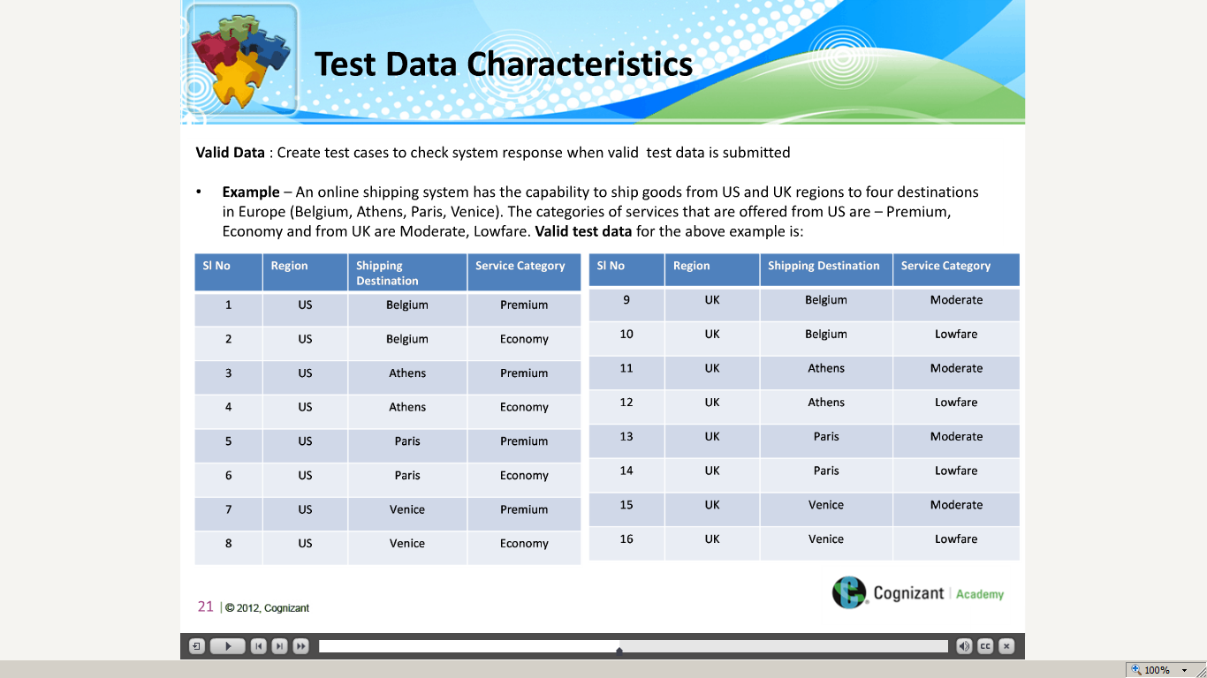](https://compass.learning.cognizant.com/elmprd/elearning/test_data_generation_methods/multiscreen.html)

[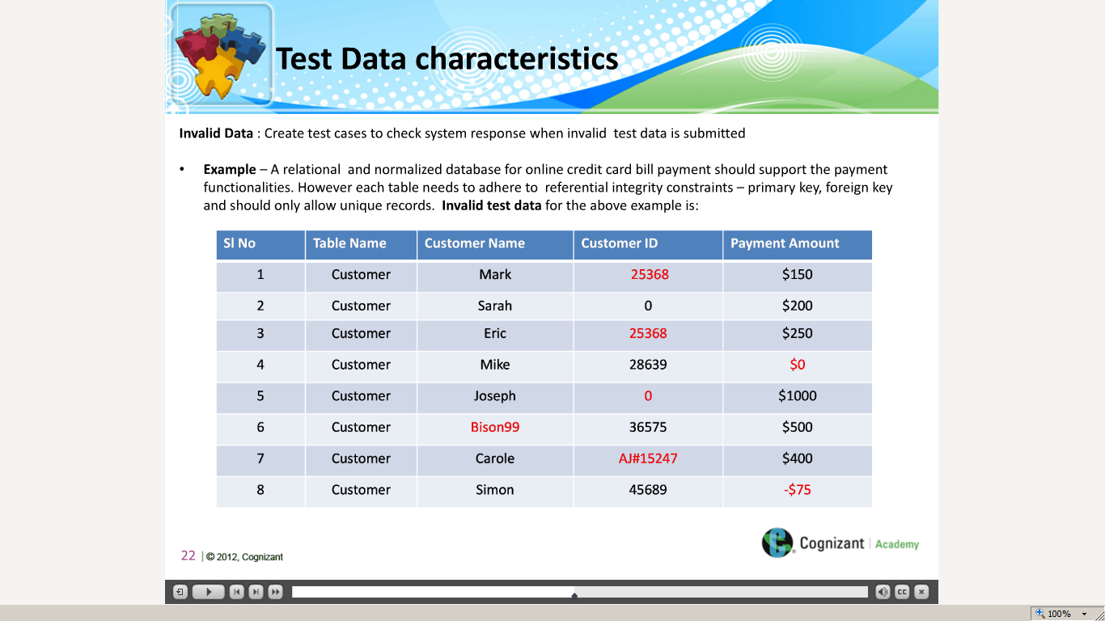](https://compass.learning.cognizant.com/elmprd/elearning/test_data_generation_methods/multiscreen.html)

[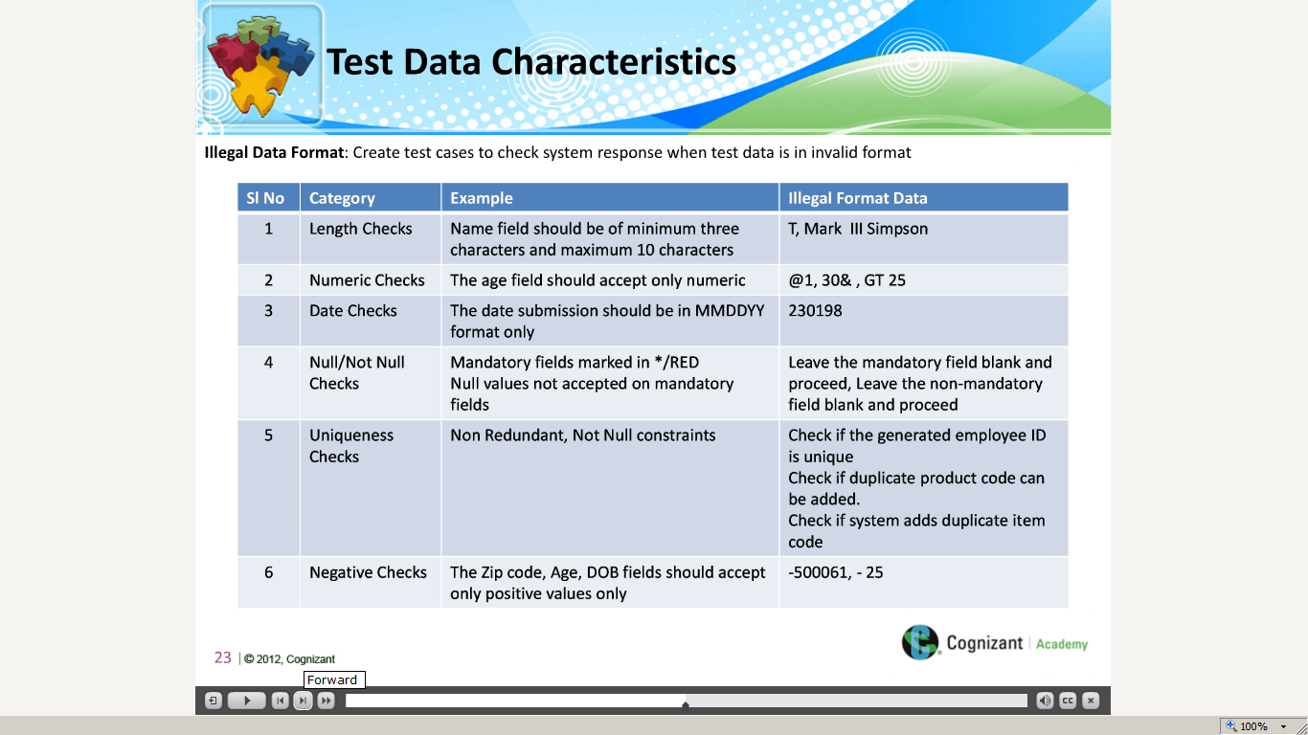](https://compass.learning.cognizant.com/elmprd/elearning/test_data_generation_methods/multiscreen.html)

[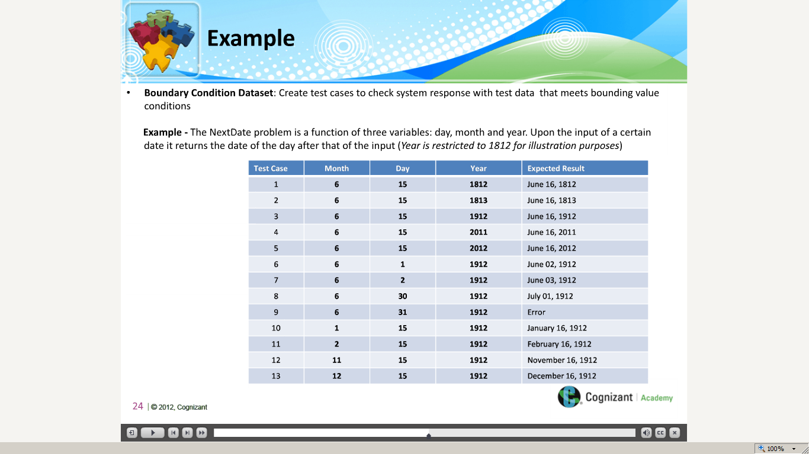](https://compass.learning.cognizant.com/elmprd/elearning/test_data_generation_methods/multiscreen.html)

[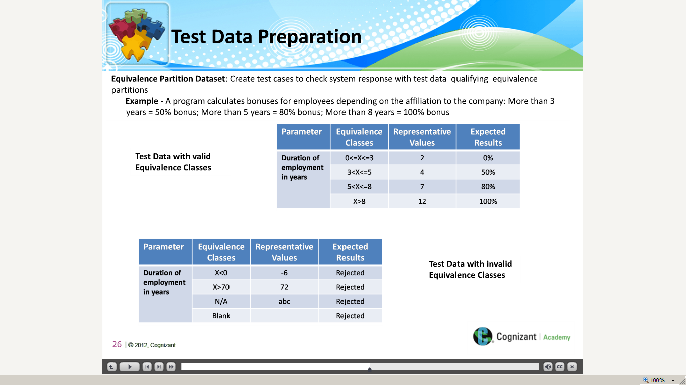](https://compass.learning.cognizant.com/elmprd/elearning/test_data_generation_methods/multiscreen.html)

[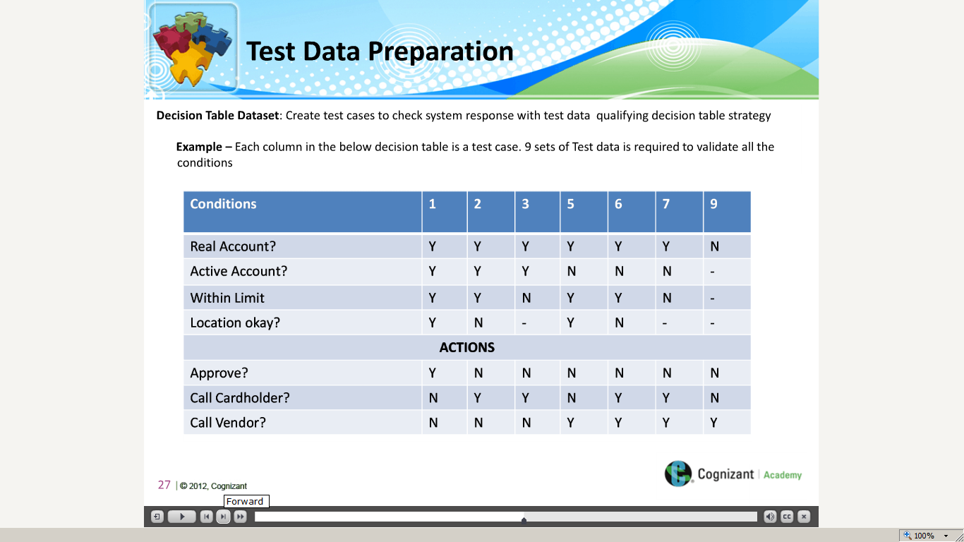](https://compass.learning.cognizant.com/elmprd/elearning/test_data_generation_methods/multiscreen.html)

[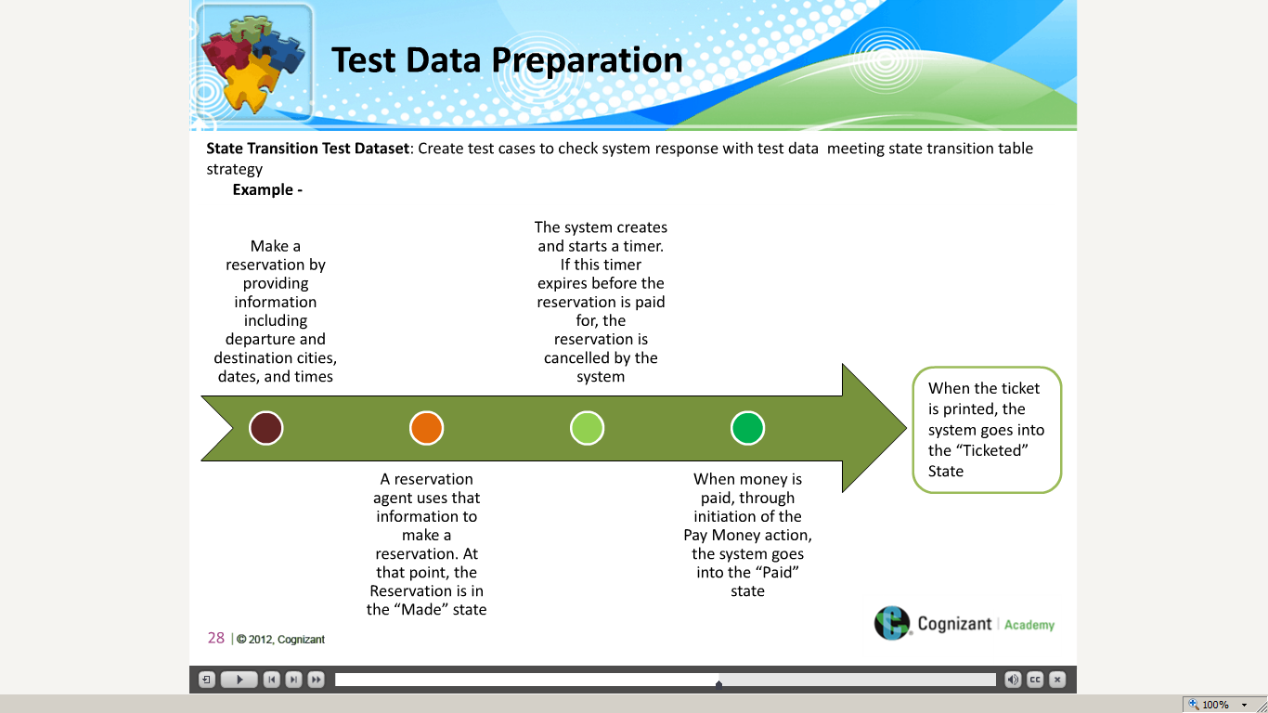](https://compass.learning.cognizant.com/elmprd/elearning/test_data_generation_methods/multiscreen.html)

[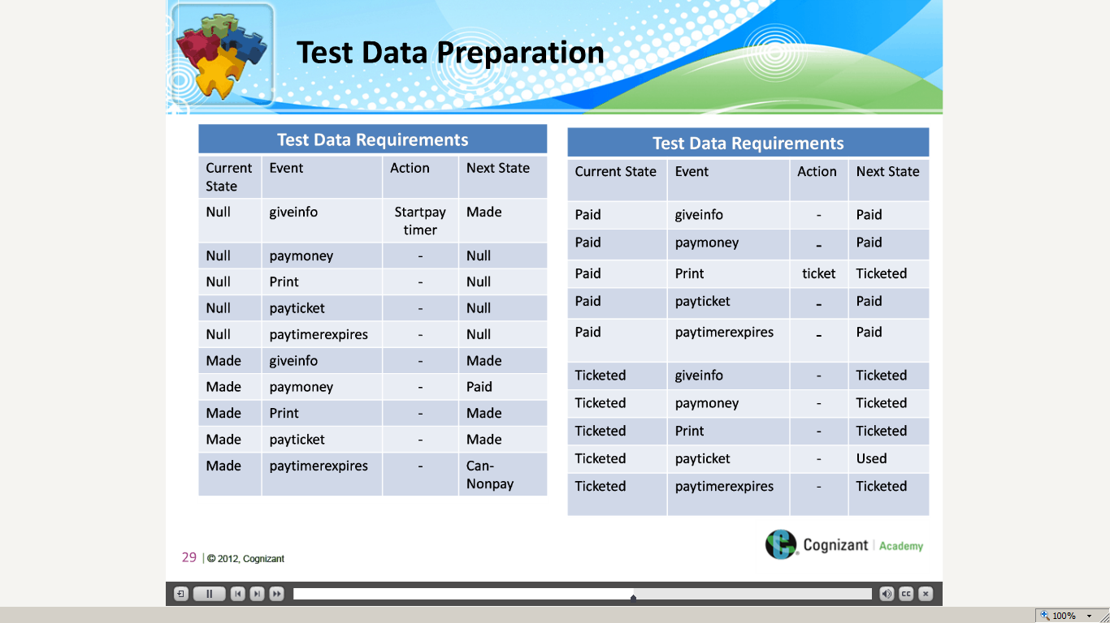](https://compass.learning.cognizant.com/elmprd/elearning/test_data_generation_methods/multiscreen.html)

[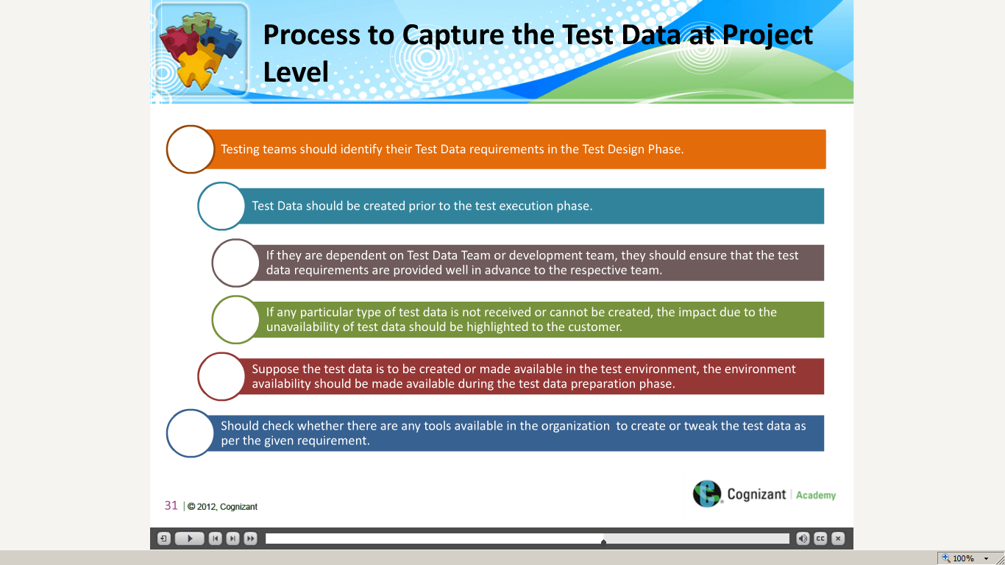](https://compass.learning.cognizant.com/elmprd/elearning/test_data_generation_methods/multiscreen.html)

[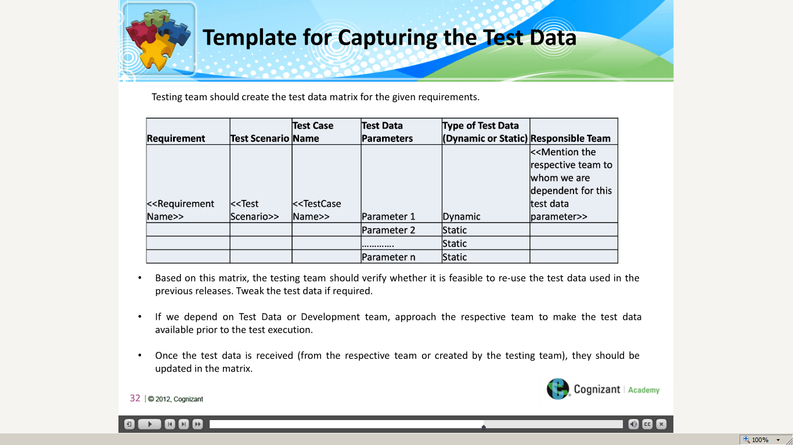](https://compass.learning.cognizant.com/elmprd/elearning/test_data_generation_methods/multiscreen.html)

[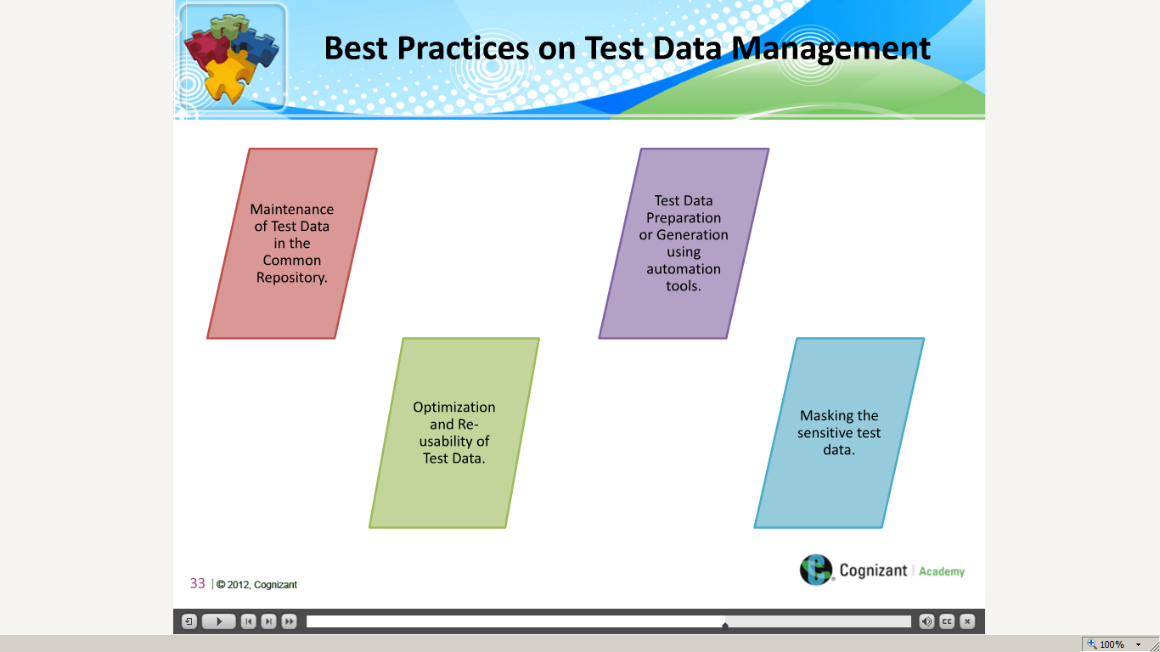](https://compass.learning.cognizant.com/elmprd/elearning/test_data_generation_methods/multiscreen.html)

[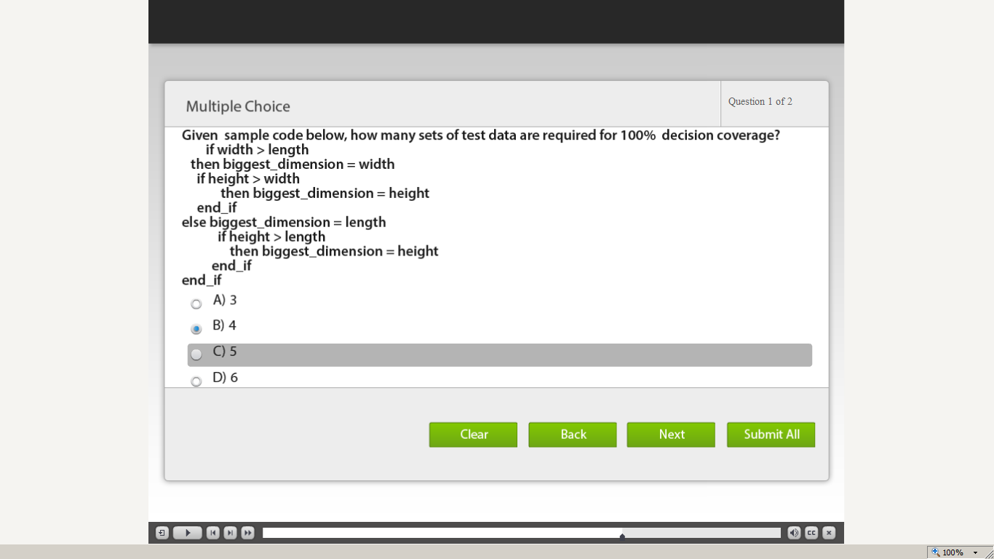](https://compass.learning.cognizant.com/elmprd/elearning/test_data_generation_methods/multiscreen.html)

[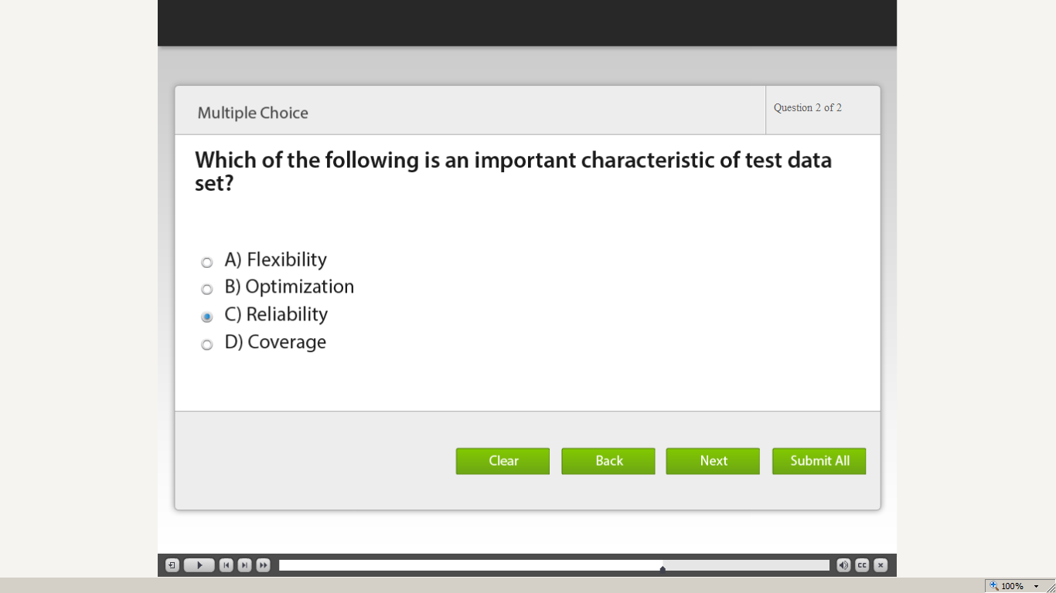](https://compass.learning.cognizant.com/elmprd/elearning/test_data_generation_methods/multiscreen.html)

[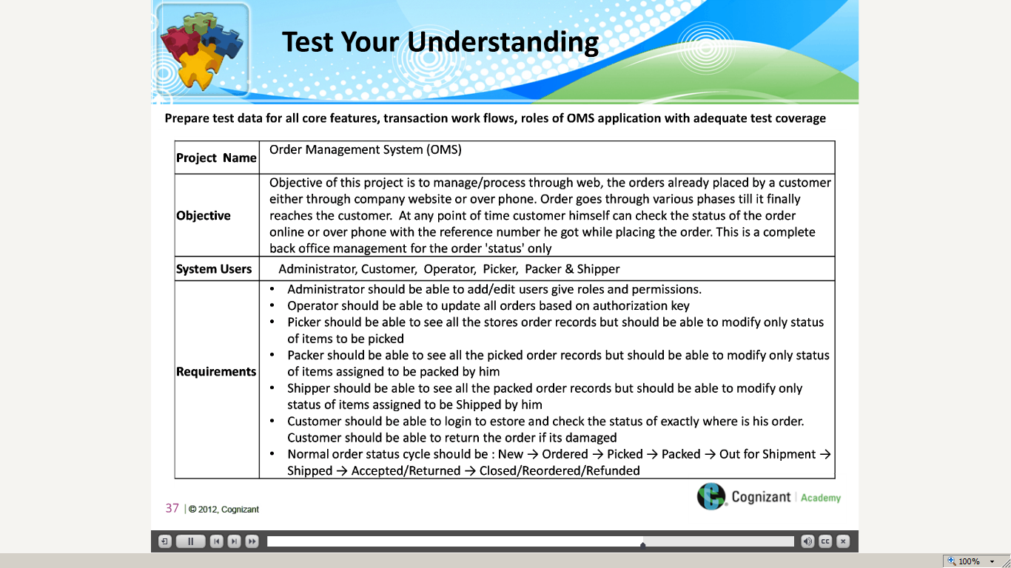](https://compass.learning.cognizant.com/elmprd/elearning/test_data_generation_methods/multiscreen.html)

[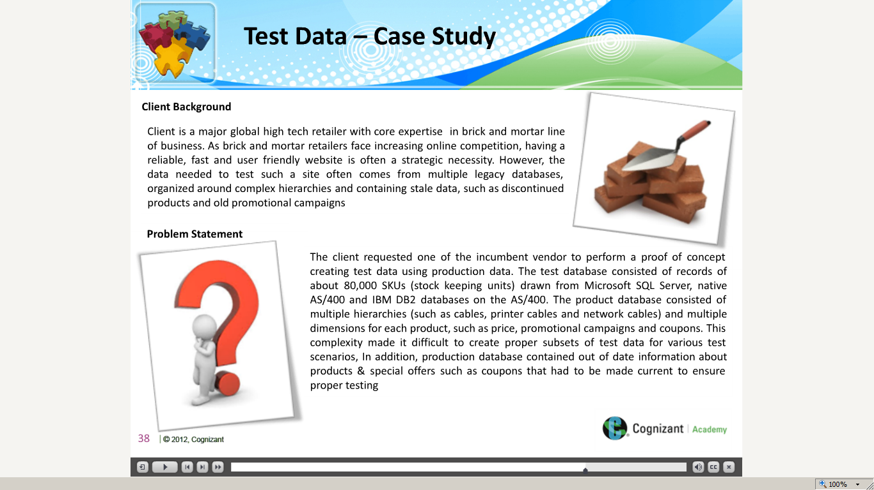](https://compass.learning.cognizant.com/elmprd/elearning/test_data_generation_methods/multiscreen.html)

[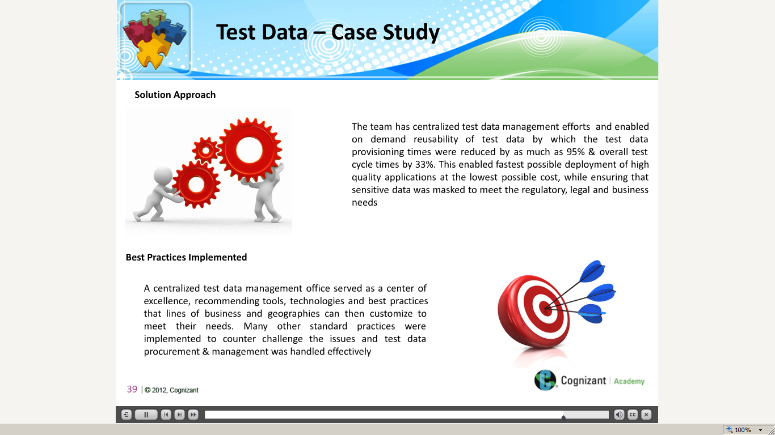](https://compass.learning.cognizant.com/elmprd/elearning/test_data_generation_methods/multiscreen.html)

[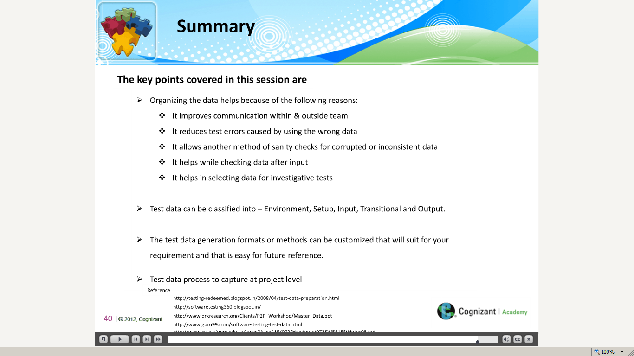](https://compass.learning.cognizant.com/elmprd/elearning/test_data_generation_methods/multiscreen.html)

[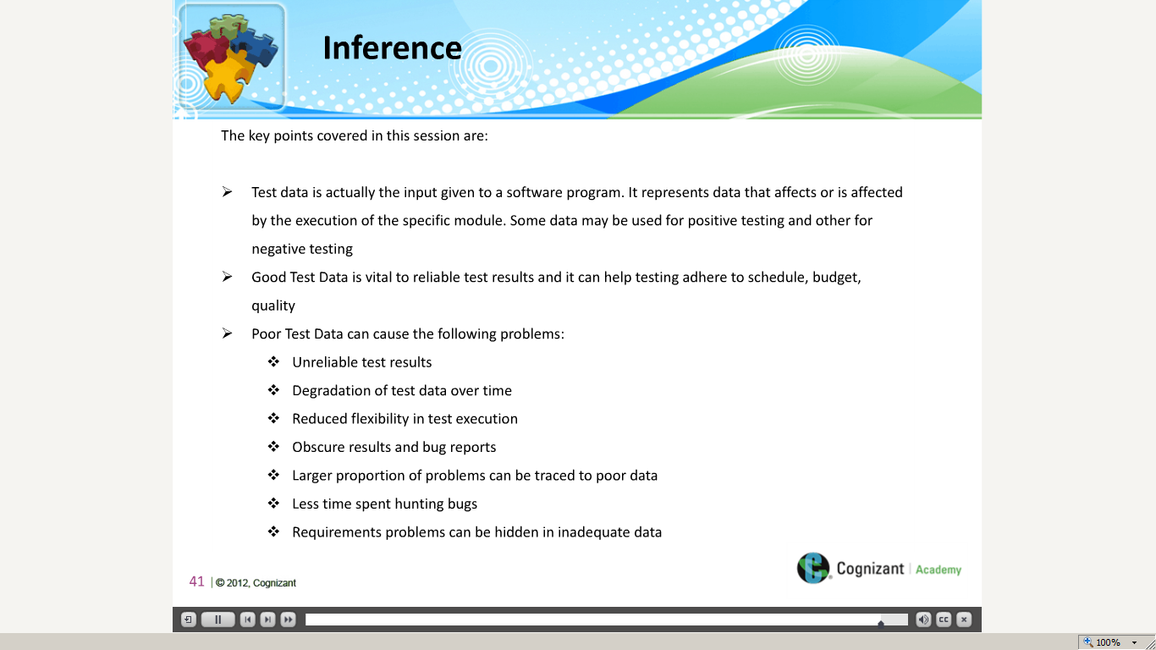](https://compass.learning.cognizant.com/elmprd/elearning/test_data_generation_methods/multiscreen.html)

Part 3

[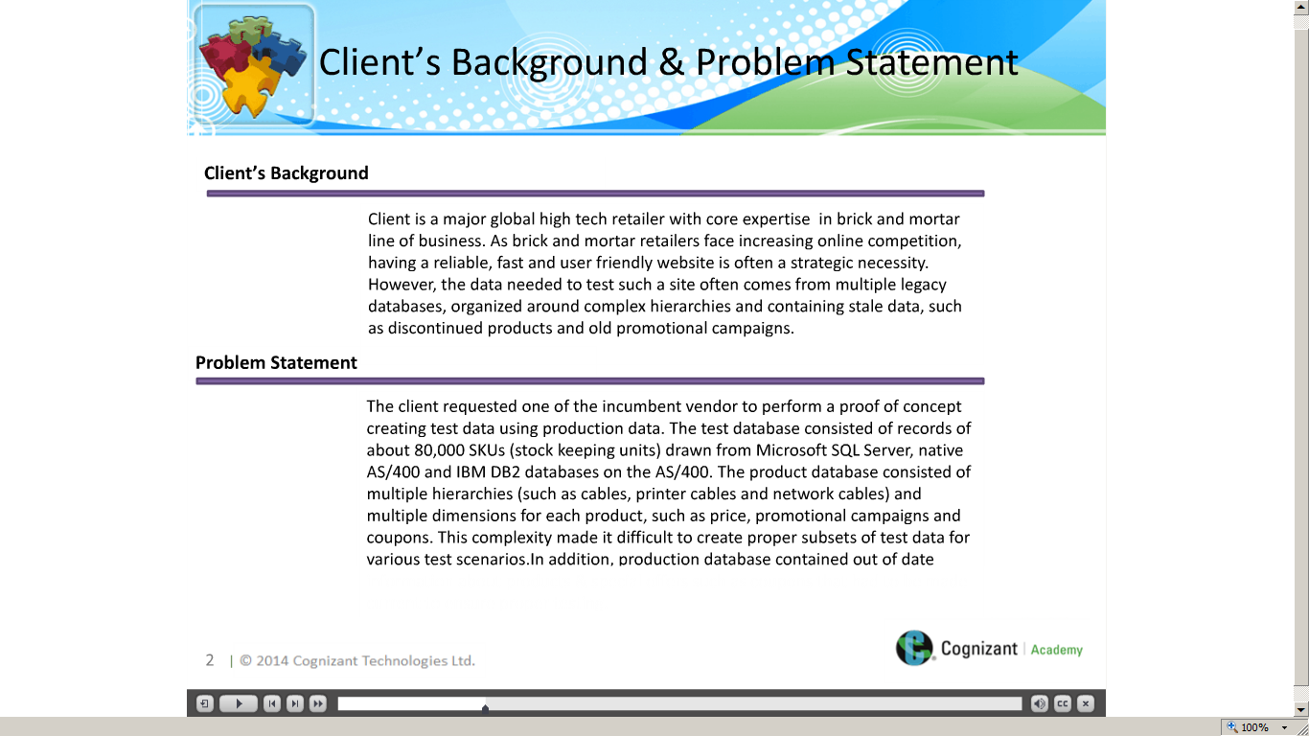](https://compass.learning.cognizant.com/elmprd/elearning/testdata_preparation_casestudy_practitioner/l2%20-%20test%20data%20preperation_case%20study_v1.htm)

[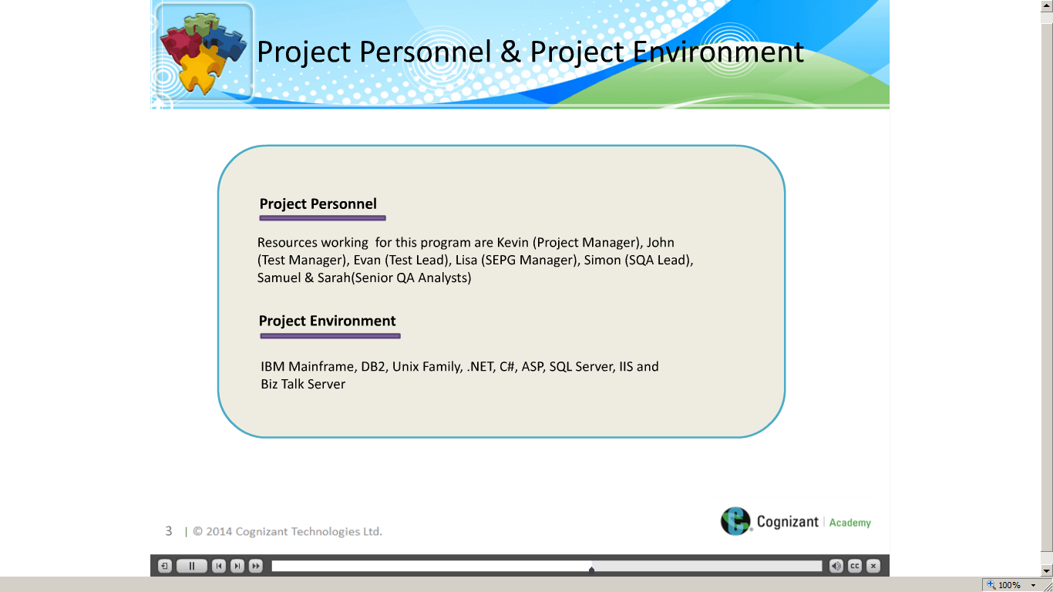](https://compass.learning.cognizant.com/elmprd/elearning/testdata_preparation_casestudy_practitioner/l2%20-%20test%20data%20preperation_case%20study_v1.htm)

[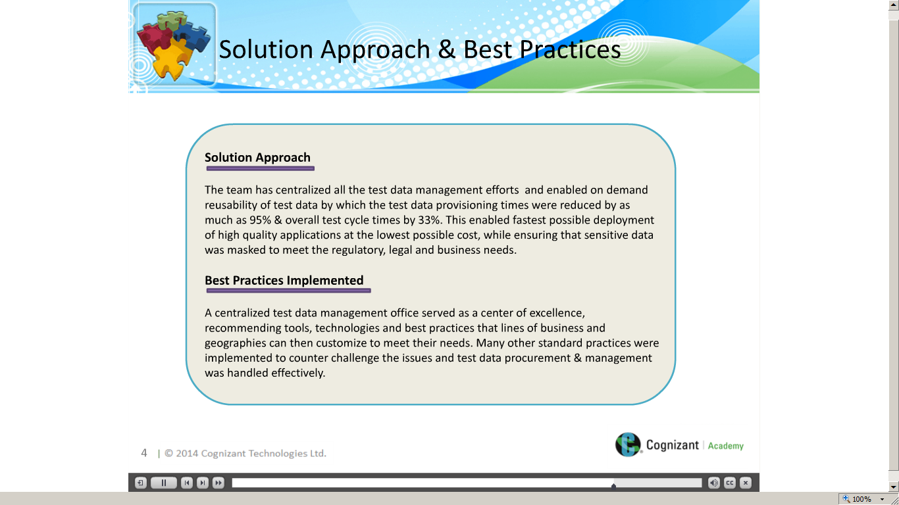](https://compass.learning.cognizant.com/elmprd/elearning/testdata_preparation_casestudy_practitioner/l2%20-%20test%20data%20preperation_case%20study_v1.htm)

[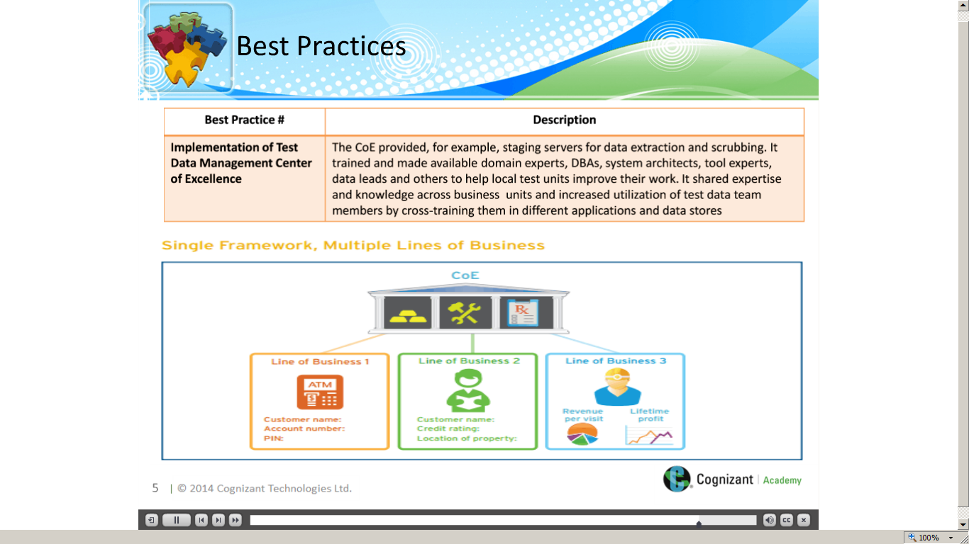](https://compass.learning.cognizant.com/elmprd/elearning/testdata_preparation_casestudy_practitioner/l2%20-%20test%20data%20preperation_case%20study_v1.htm)

[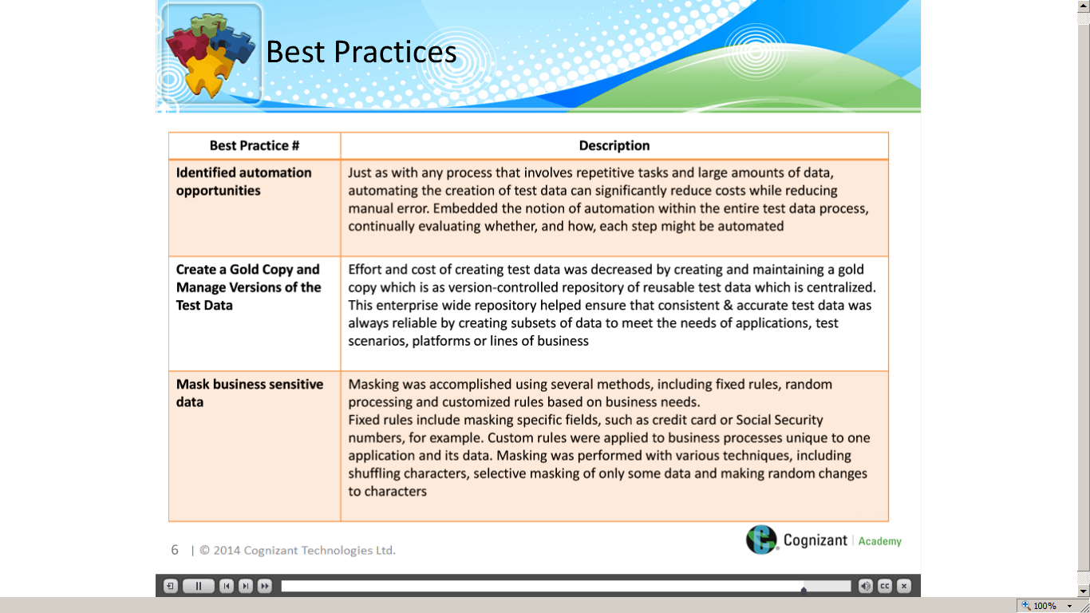](https://compass.learning.cognizant.com/elmprd/elearning/testdata_preparation_casestudy_practitioner/l2%20-%20test%20data%20preperation_case%20study_v1.htm)

[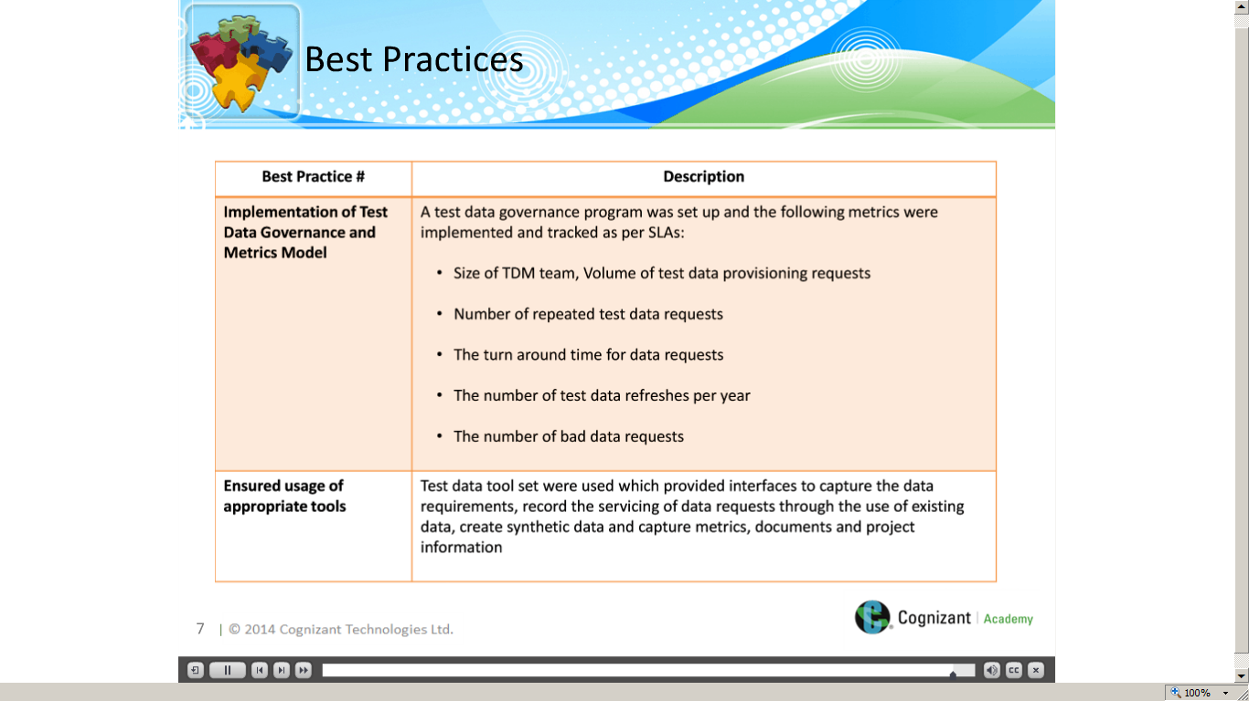](https://compass.learning.cognizant.com/elmprd/elearning/testdata_preparation_casestudy_practitioner/l2%20-%20test%20data%20preperation_case%20study_v1.htm)